**Python Introduction**: -

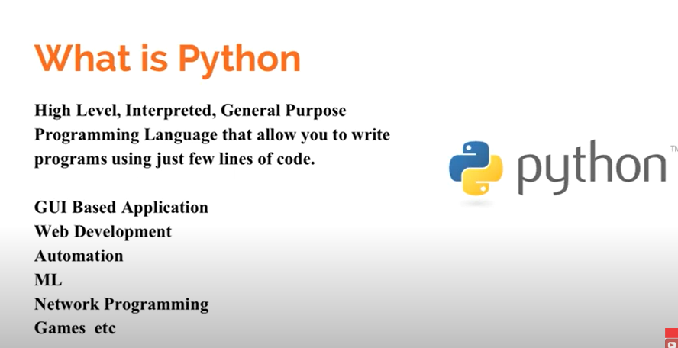

**Interpreted** – Python is Interpreted Programming Language – it means it will execute the Program code line by line, easy to use, syntax.

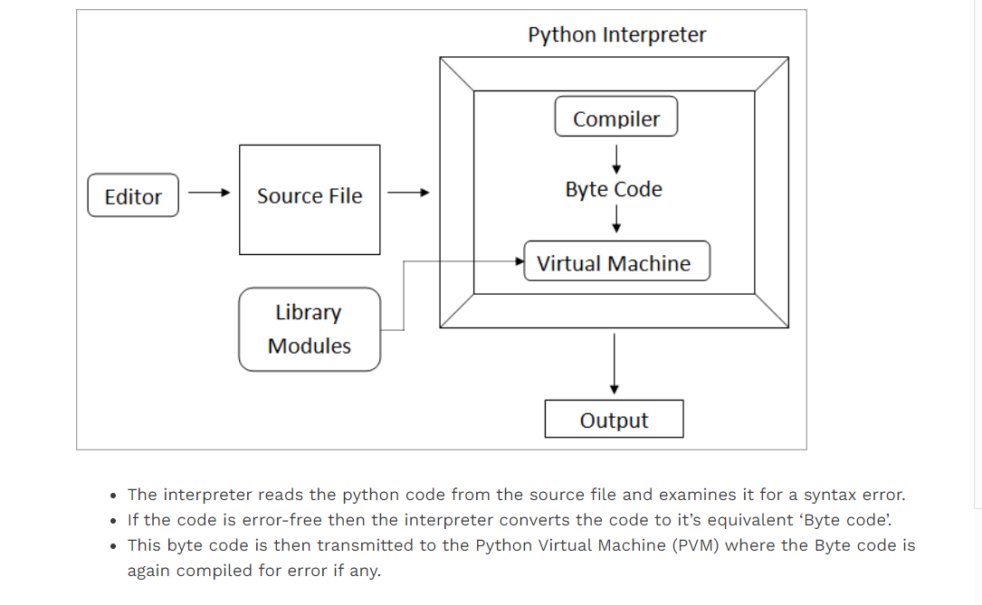

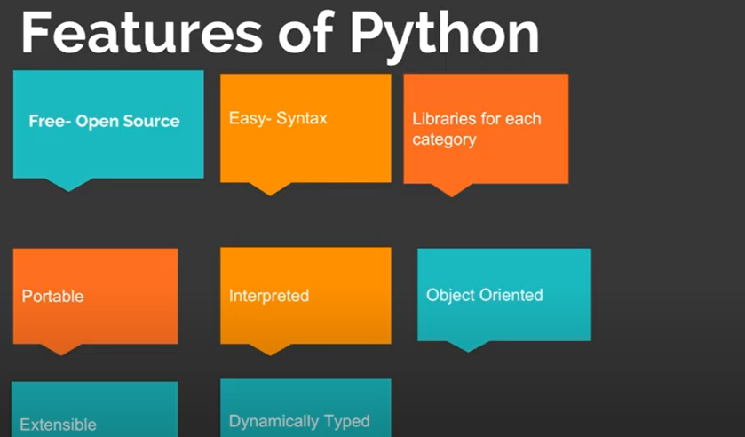

**Imp Feature of Python – it is dynamically typed** – we don’t need to call out the variable whether it is string, integer – we just need to mention the name of the variable and start to use it.

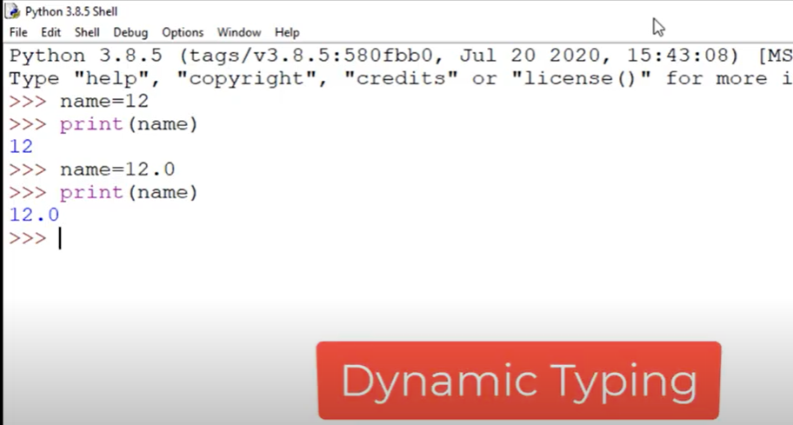

**Python – Data types**: -

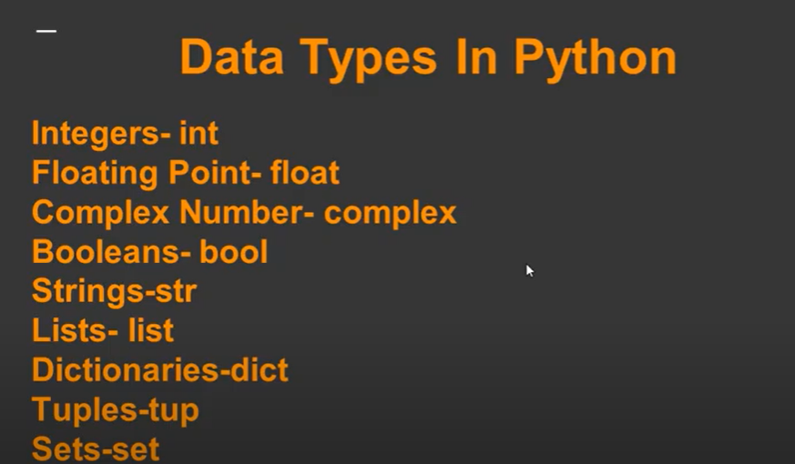

**Each data type in Python is class**

**Integer: -**

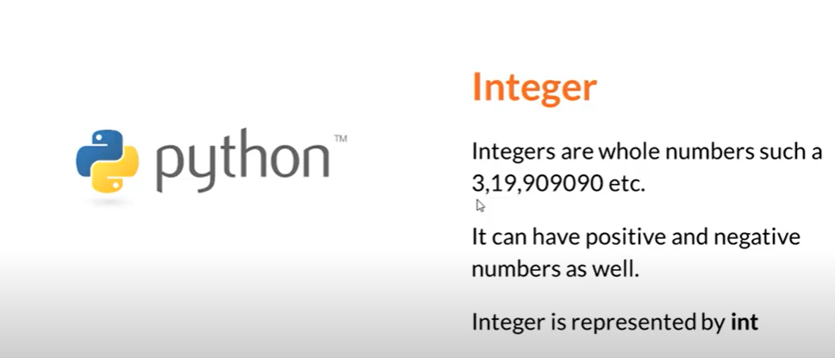

**Float**

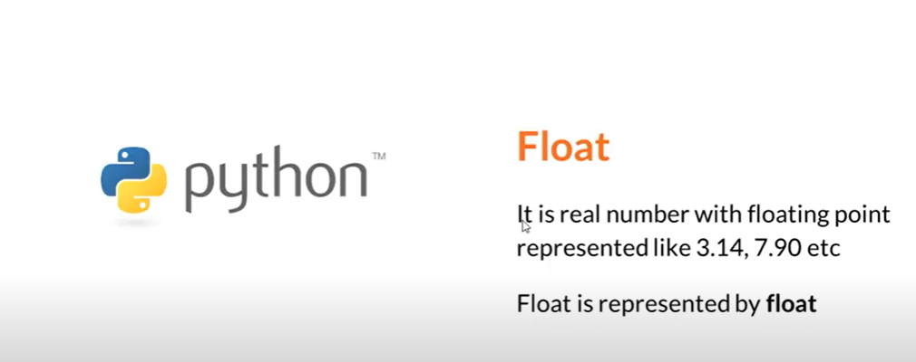

**Complex Number :-**

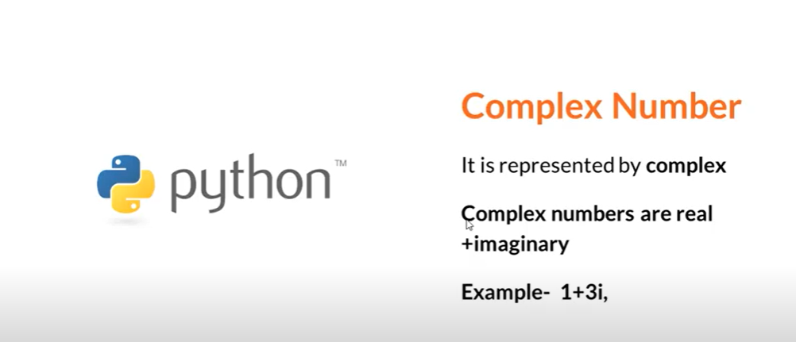

**Boolean :-**

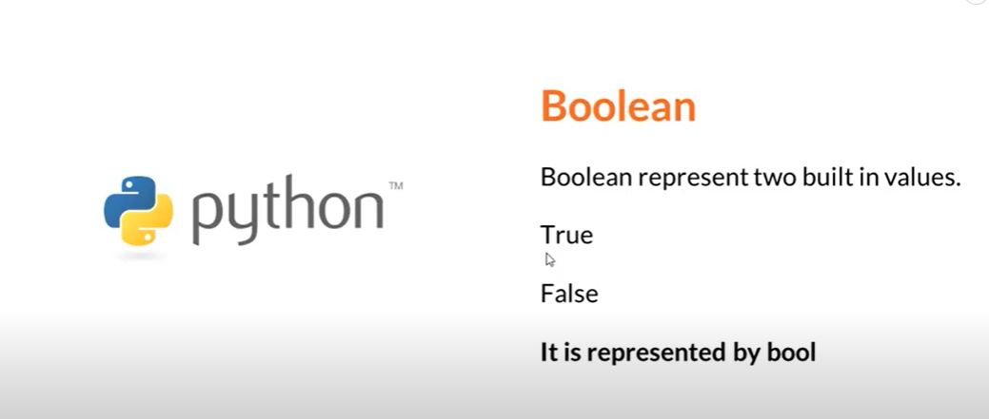

**Strings: -**

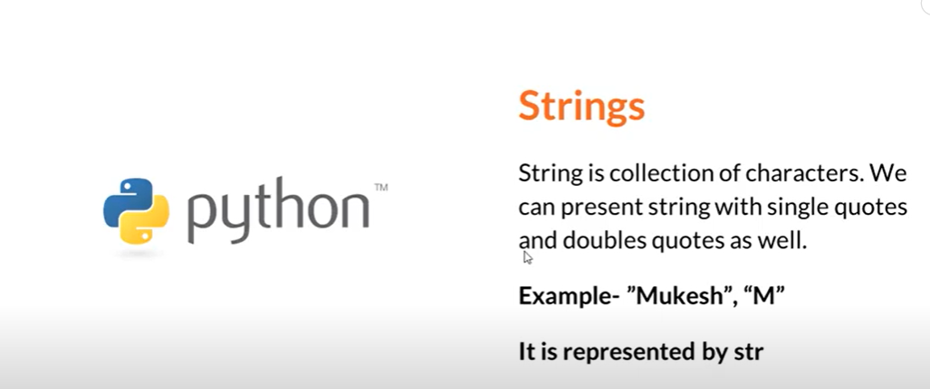

**Python don’t have any character data type**

**List :-**

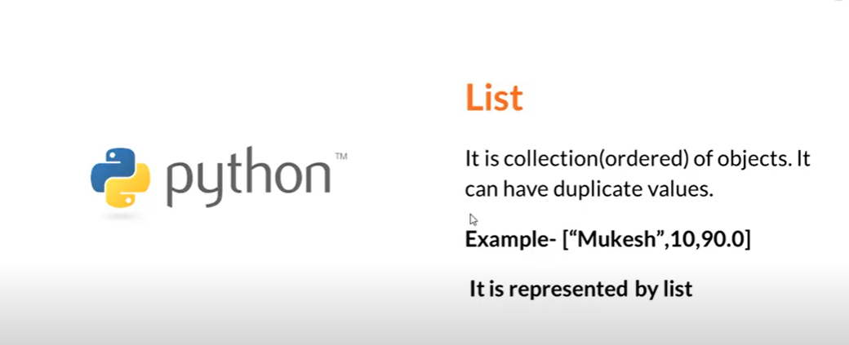

**Set**

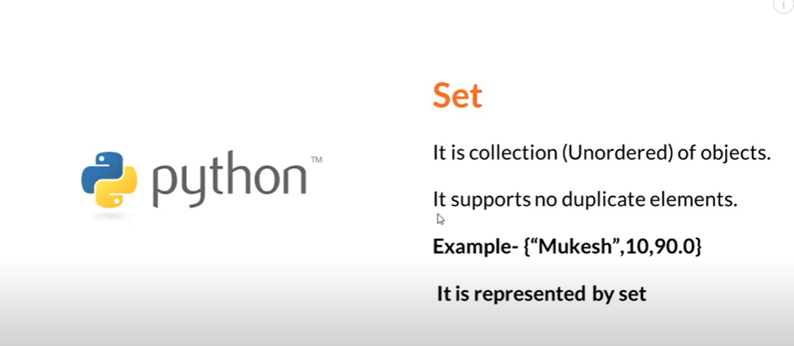

**Dictionary**:

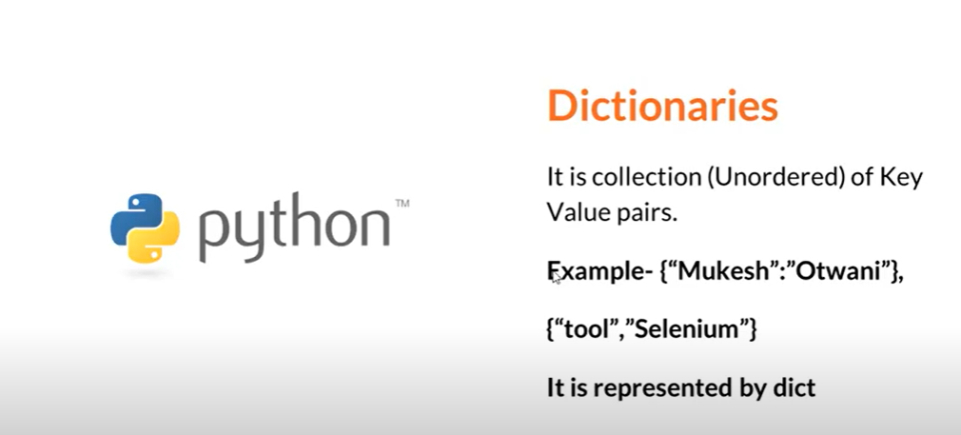

**Tuples** :-

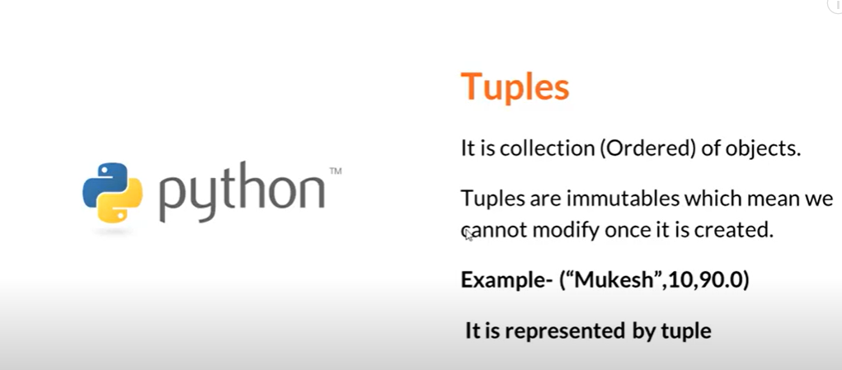

TO check for any data type – use the type function – it will give the class of the data type

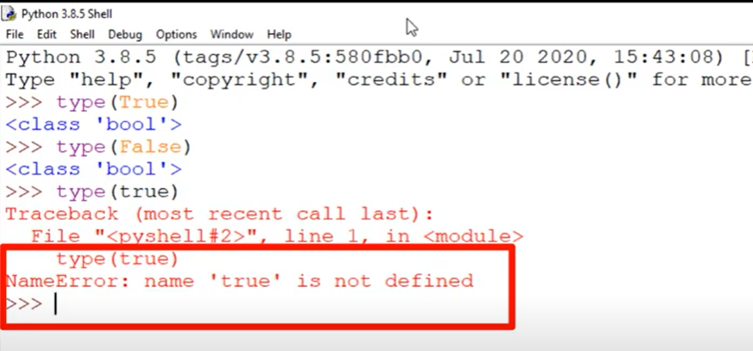

Variables in python should start with lower case: -

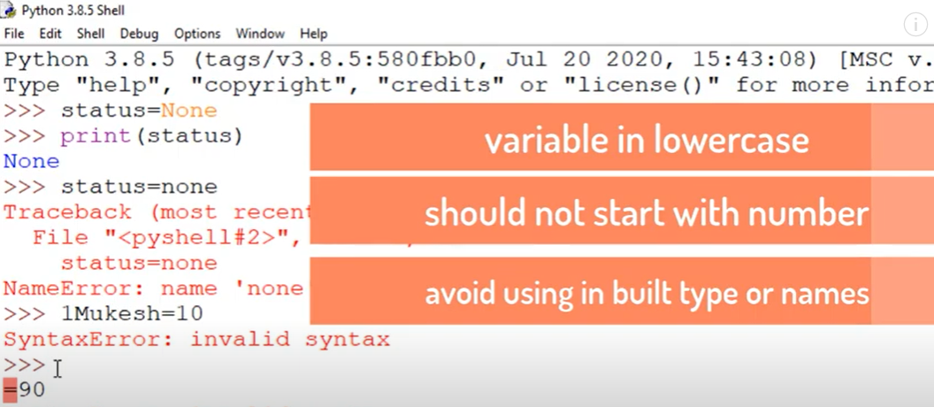

**Installation of Python**: -

How to install python

Download the python version from the python site

Downloaded the python 3.8 version

It will get installed at the following location

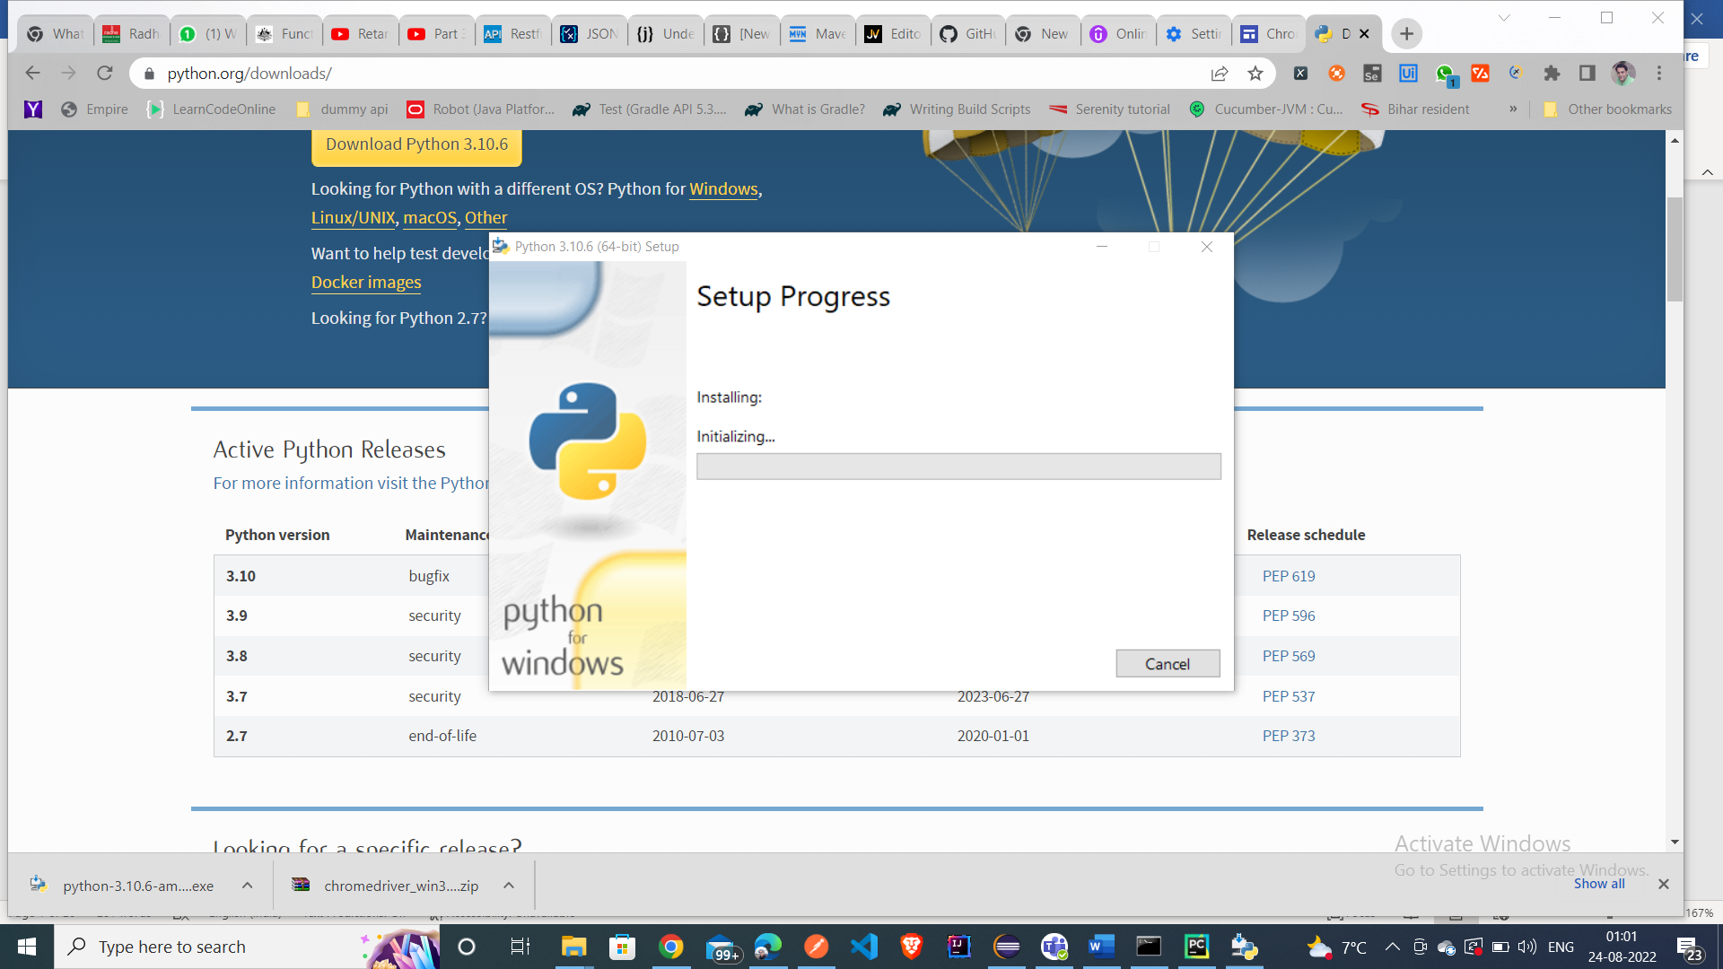

C:\Users\ACER\AppData\Local\Programs\Python\Python38-32

C:\Users\ACER\AppData\Local\Programs\Python\Python38-32\Scripts

* Pip application it will download all the libraries

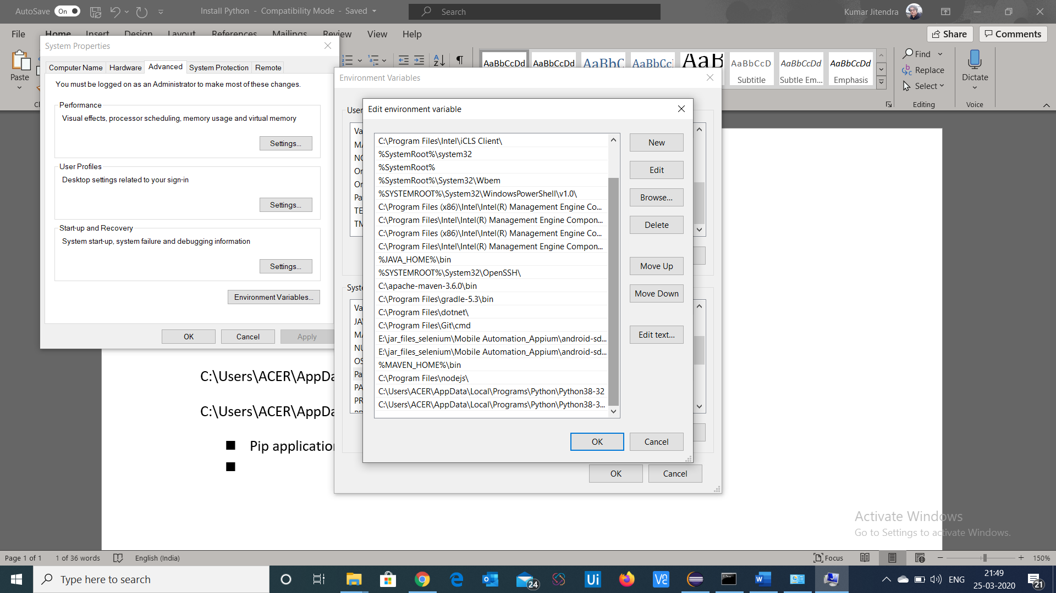’Add the path variables at the environment variables path

Check the pip installation

At command prompt type – pip

Update the System Variables :-

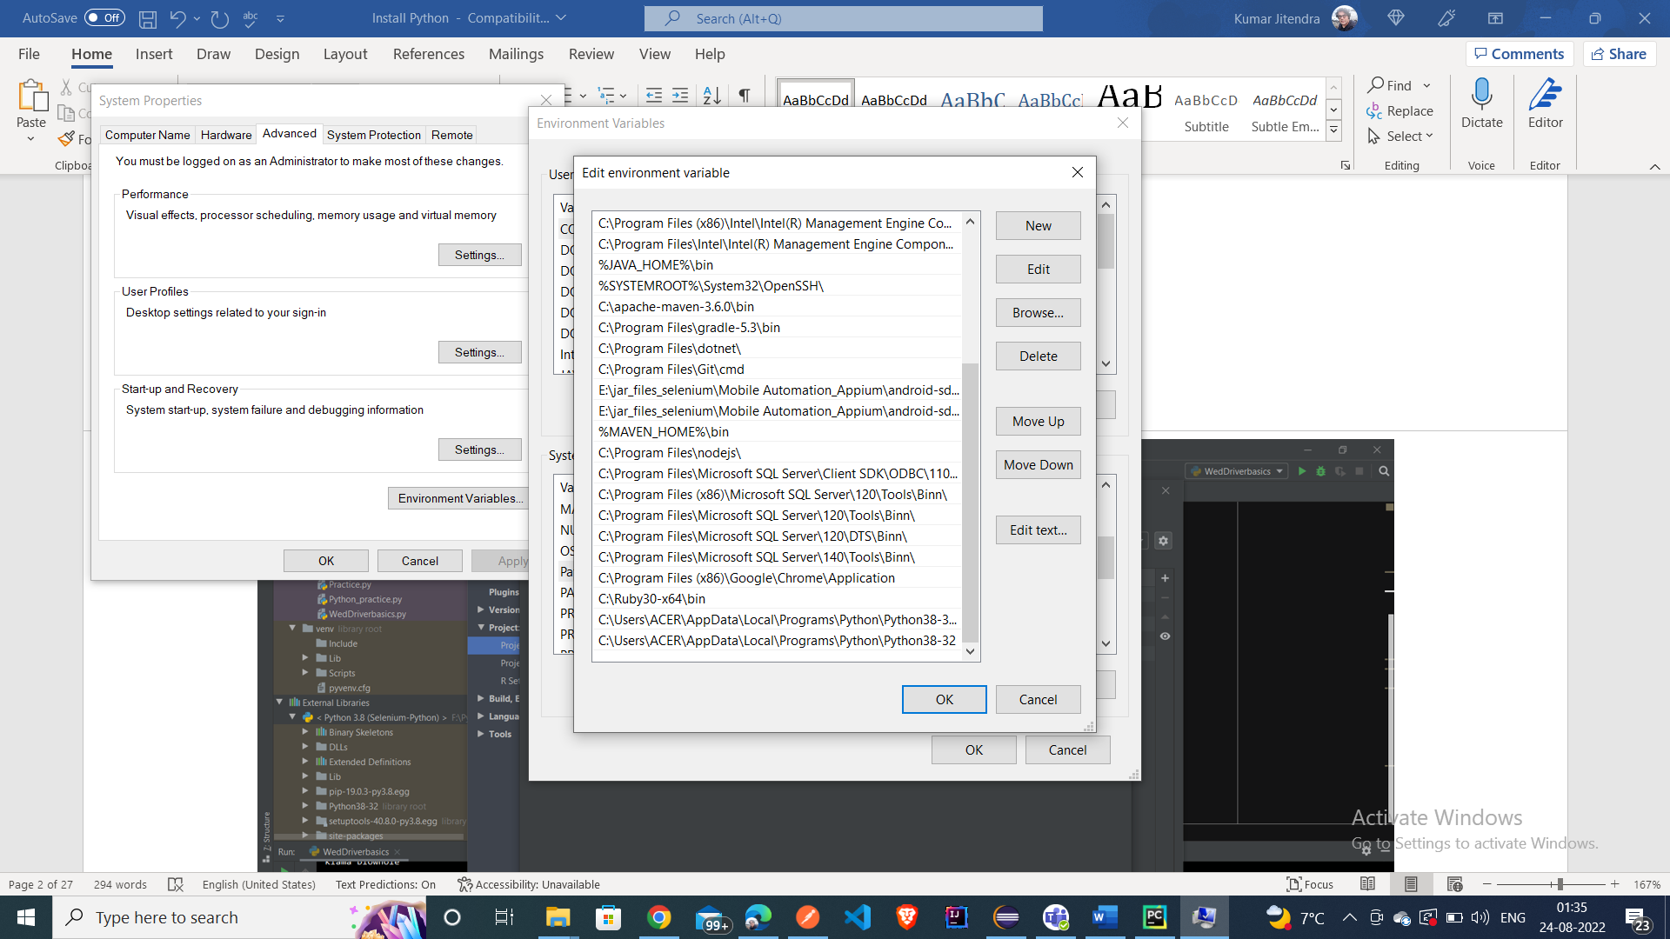

Change the Python Installation in the Pycharm IDE

Verify the python installation

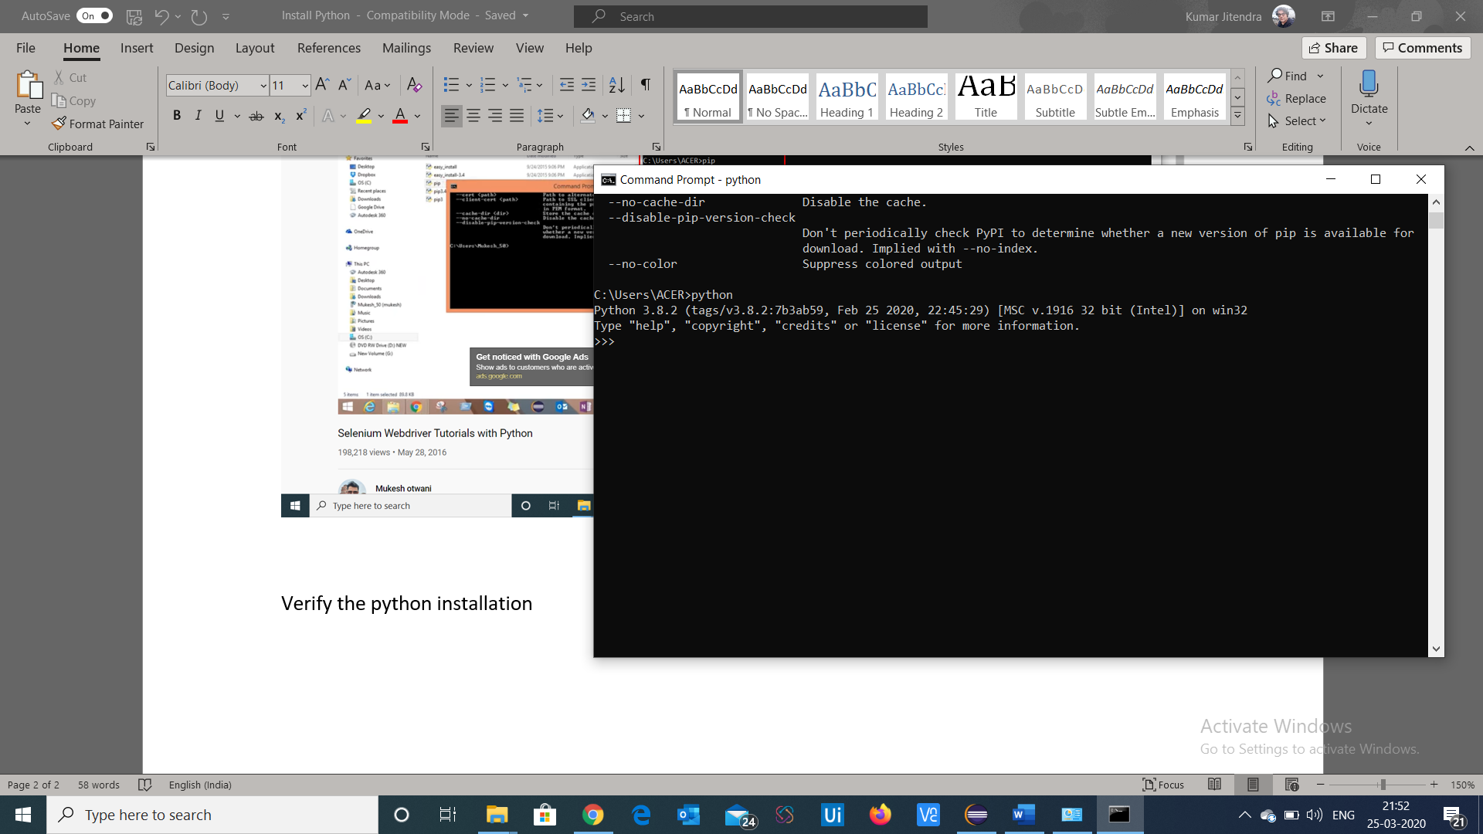

Check the version of the python

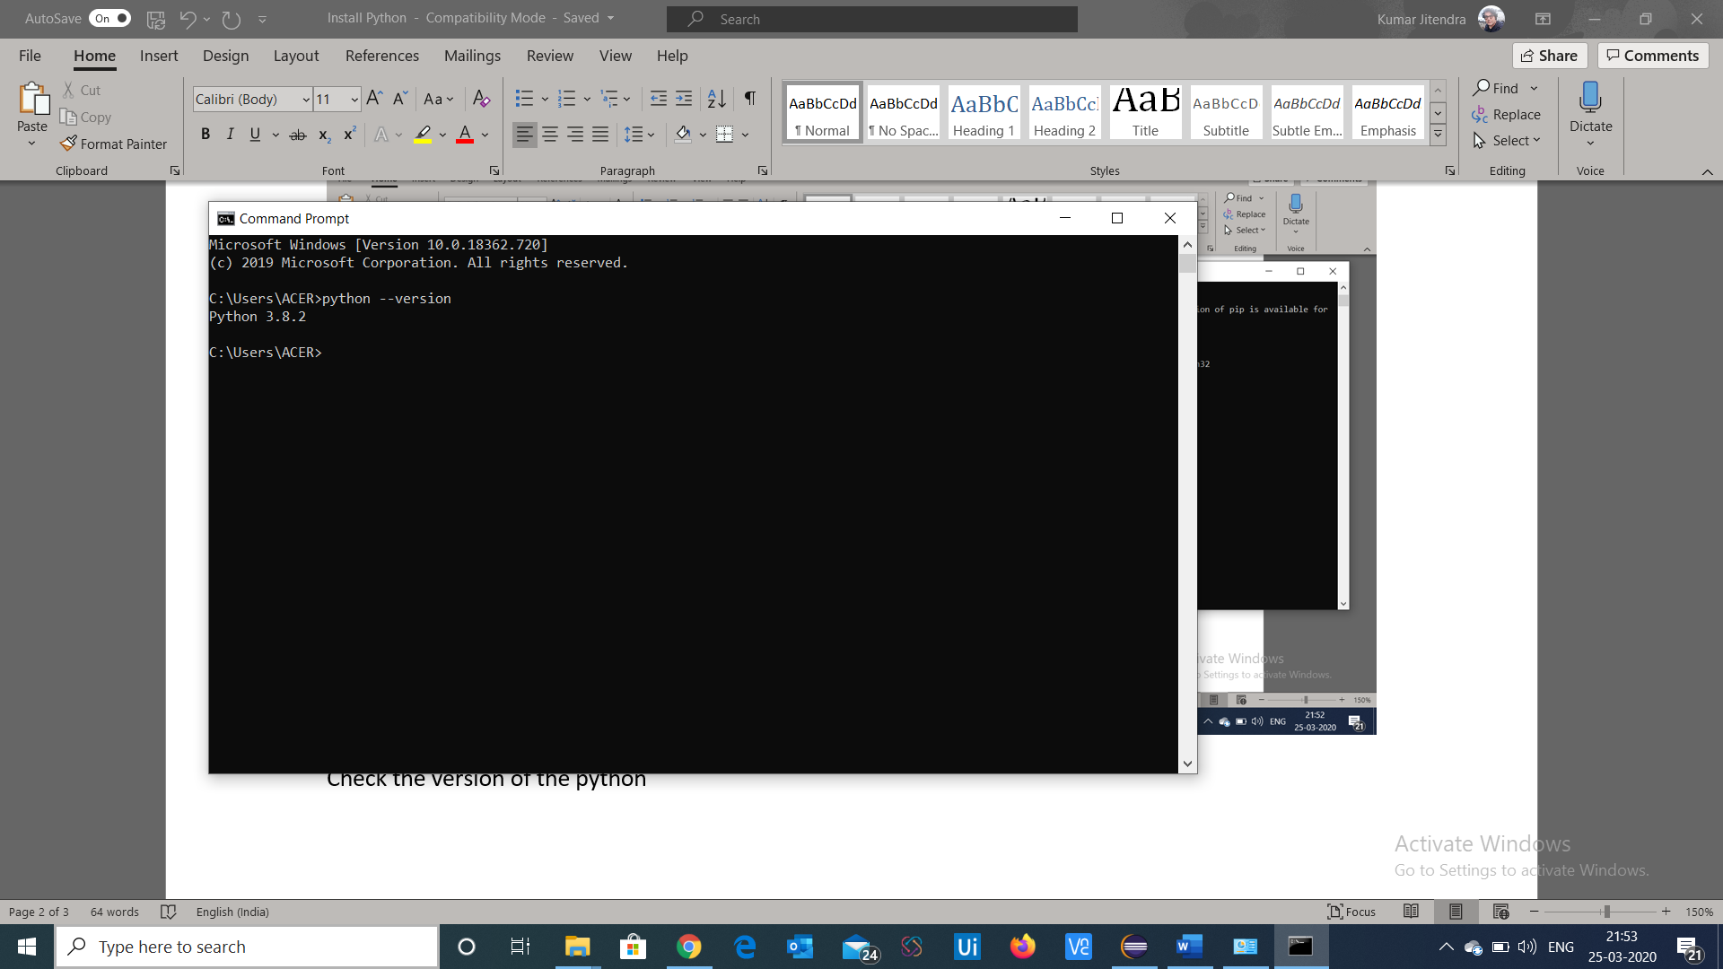

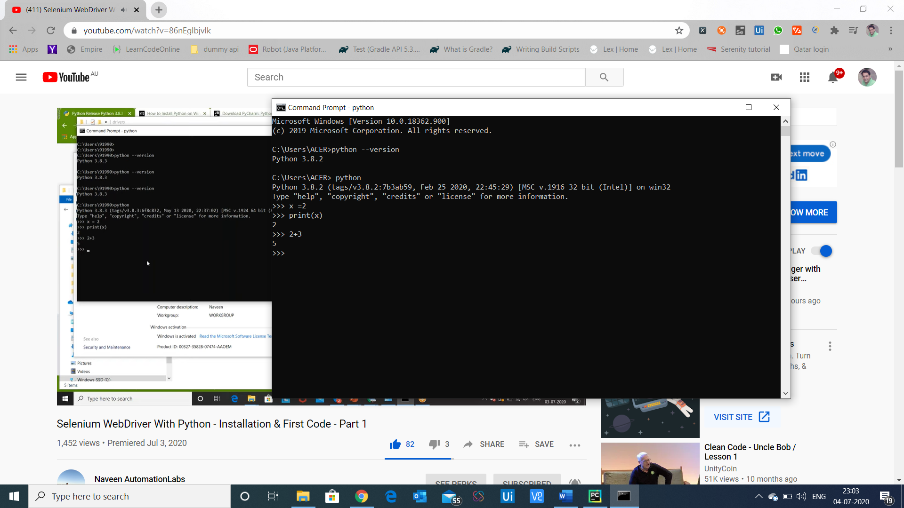

Evaluate variables inside python

Download the pycharm IDE

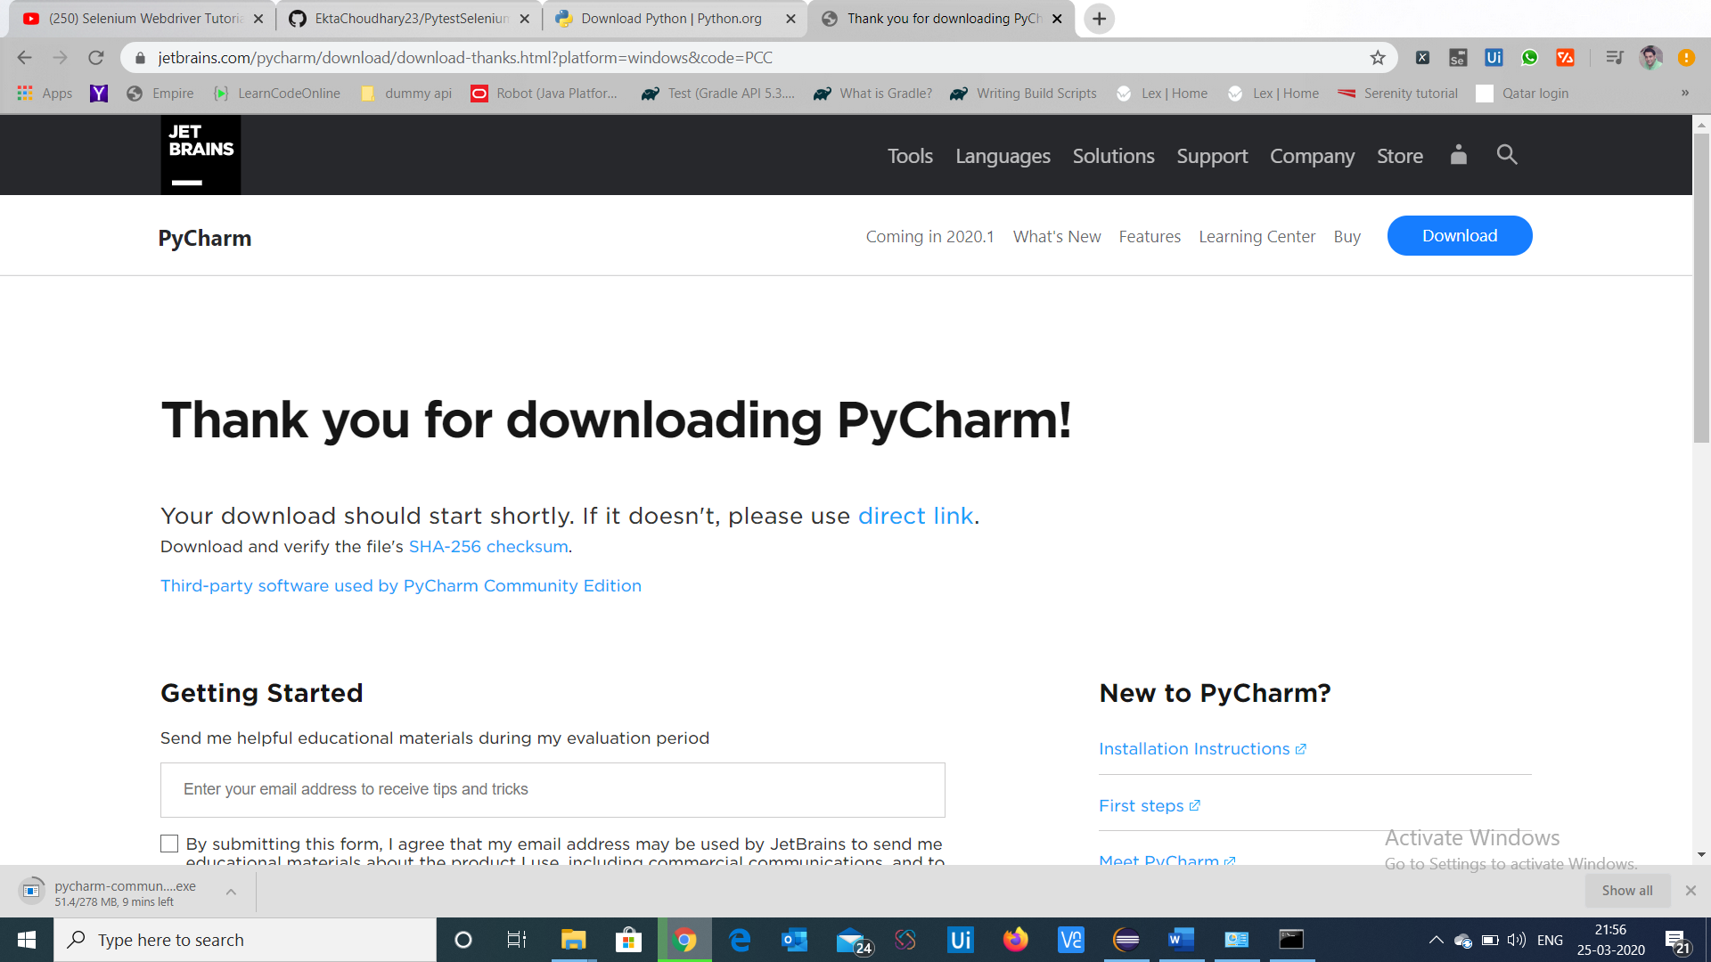

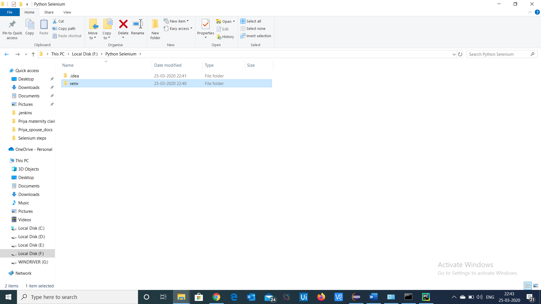

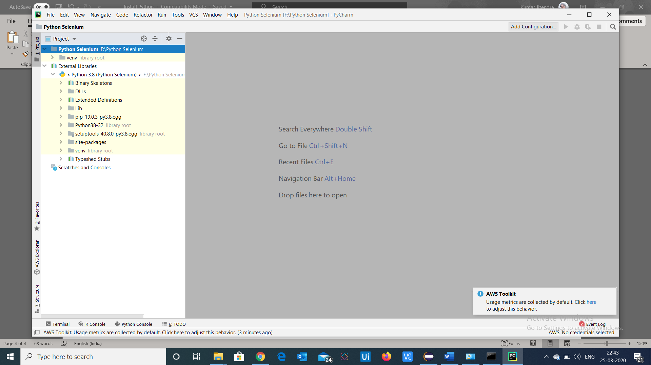

Python Selenium folder is created

At the External Libraries Section all the libraries will be there

After creating package create new Python file

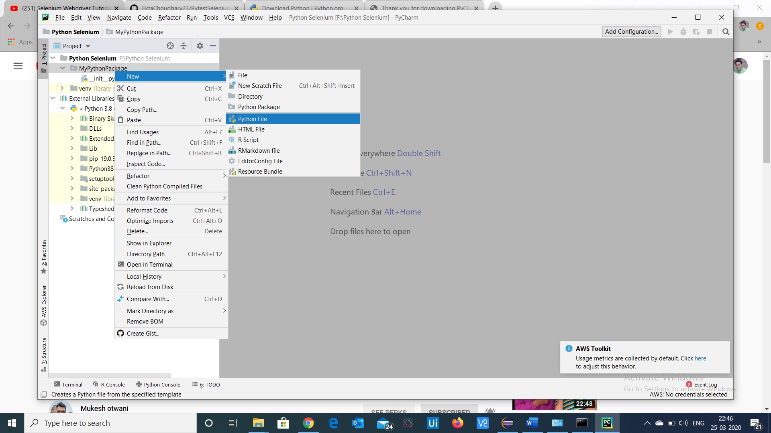

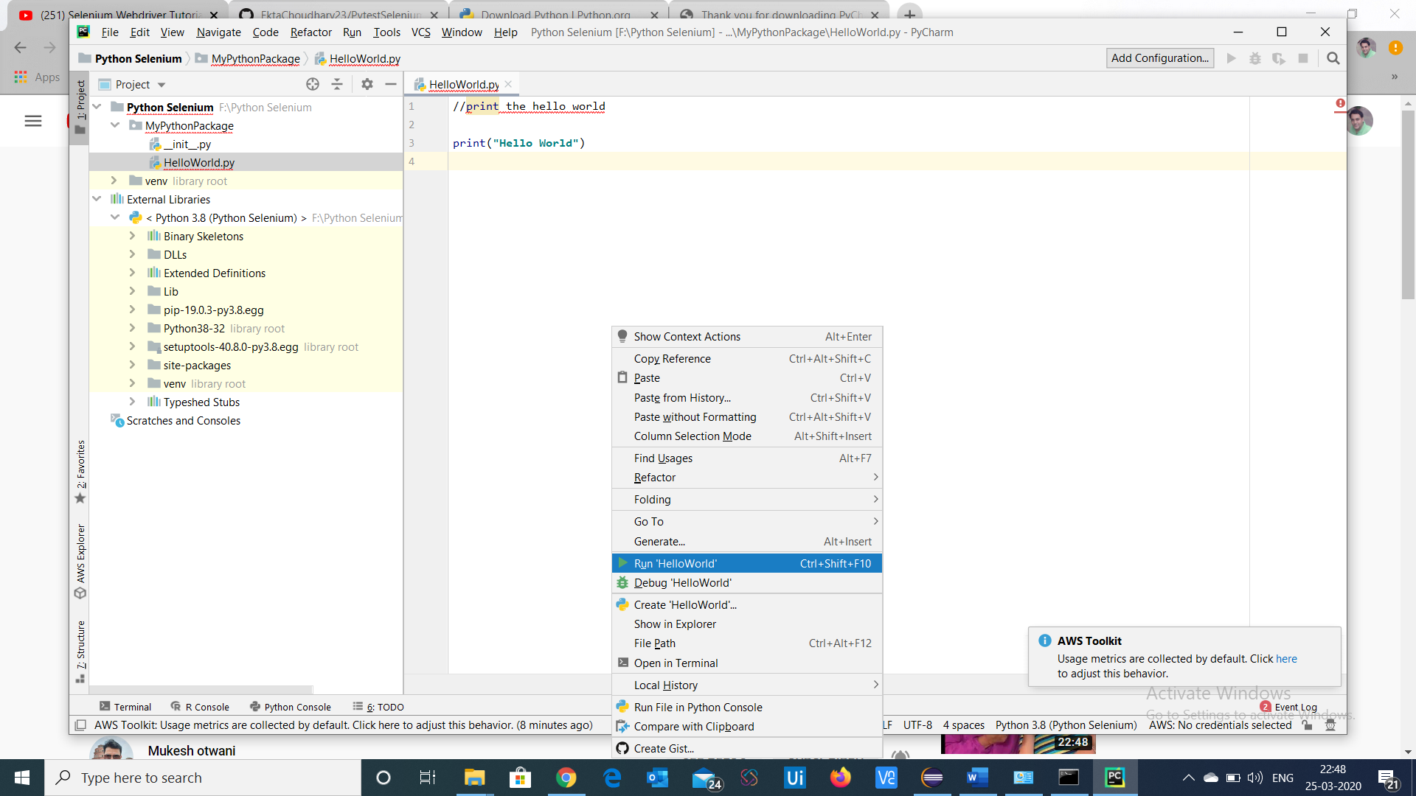

Run Helloworld

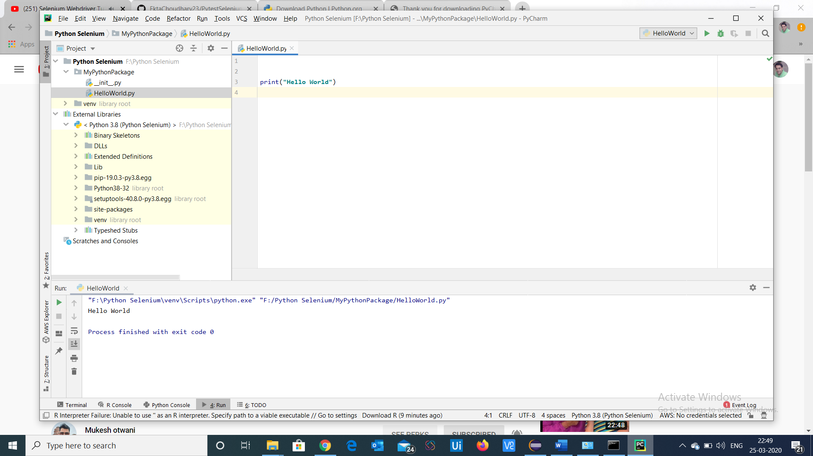

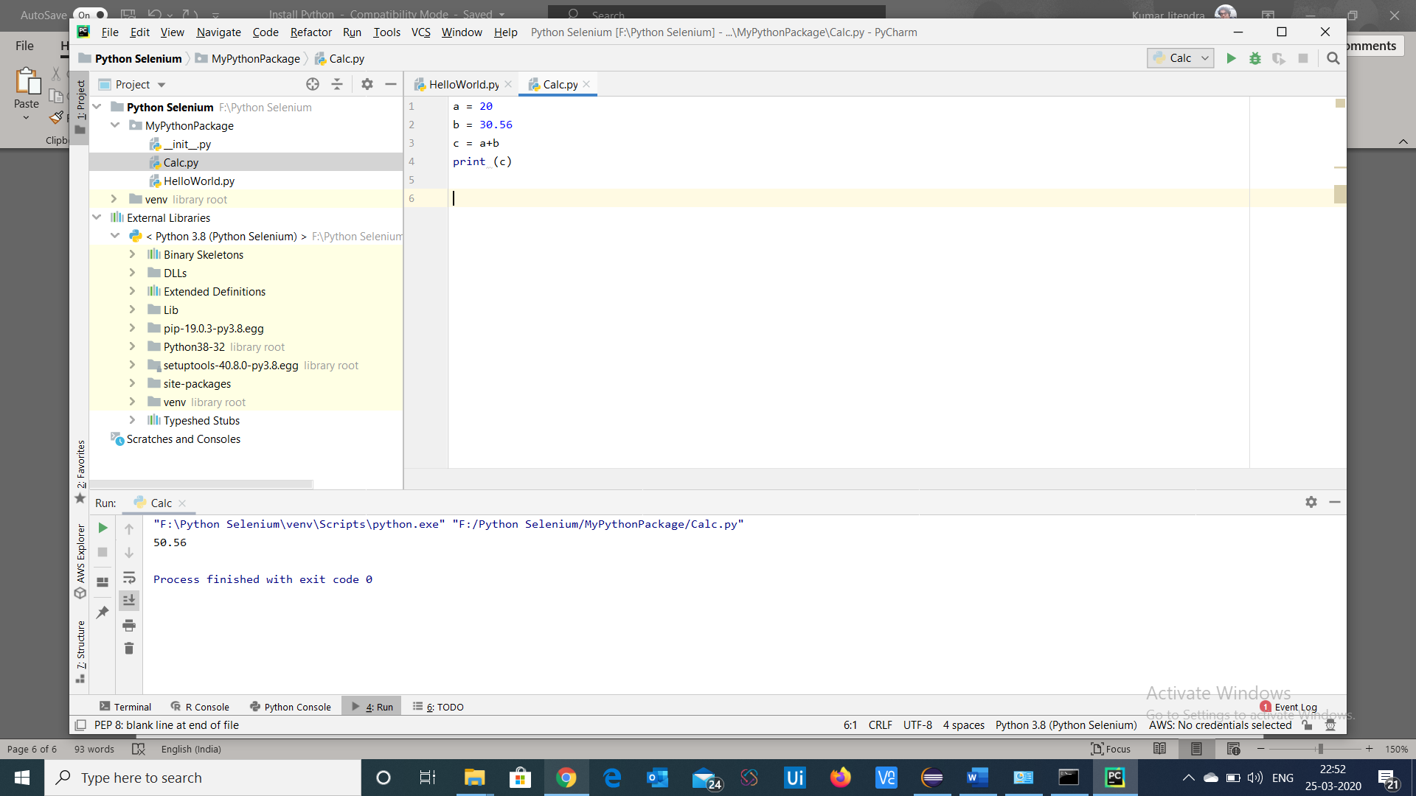

At run time it takes the data types

9013151515

To install the selenium libraries

Command – pip install -U selenium

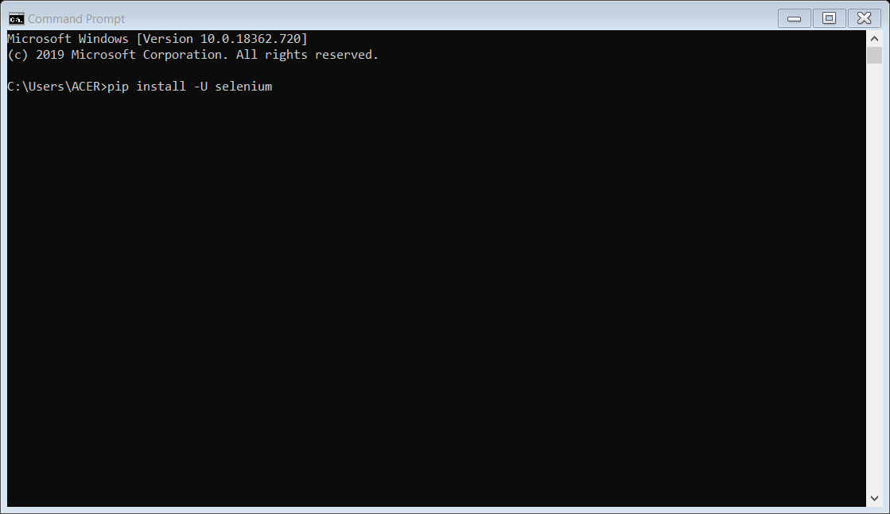

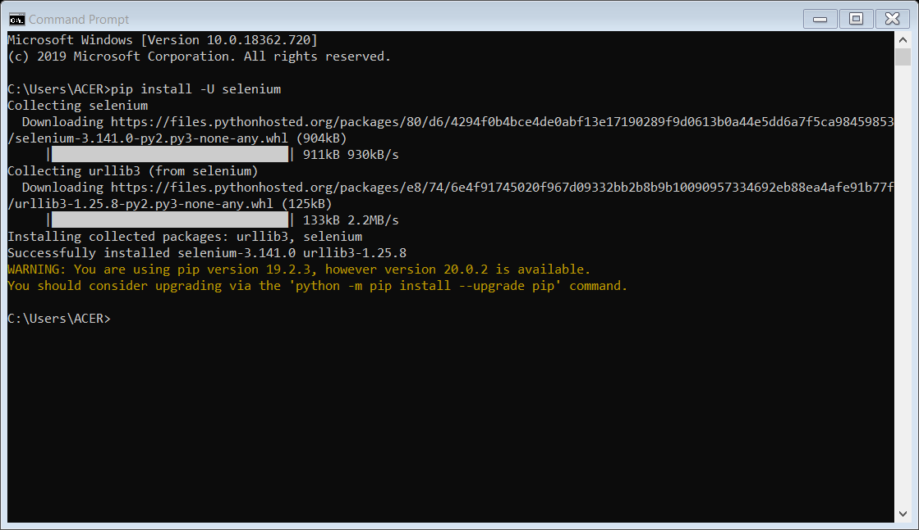

At this path selenium libraries will be installed

C:\Users\ACER\AppData\Local\Programs\Python\Python38-32\Lib\site-packages

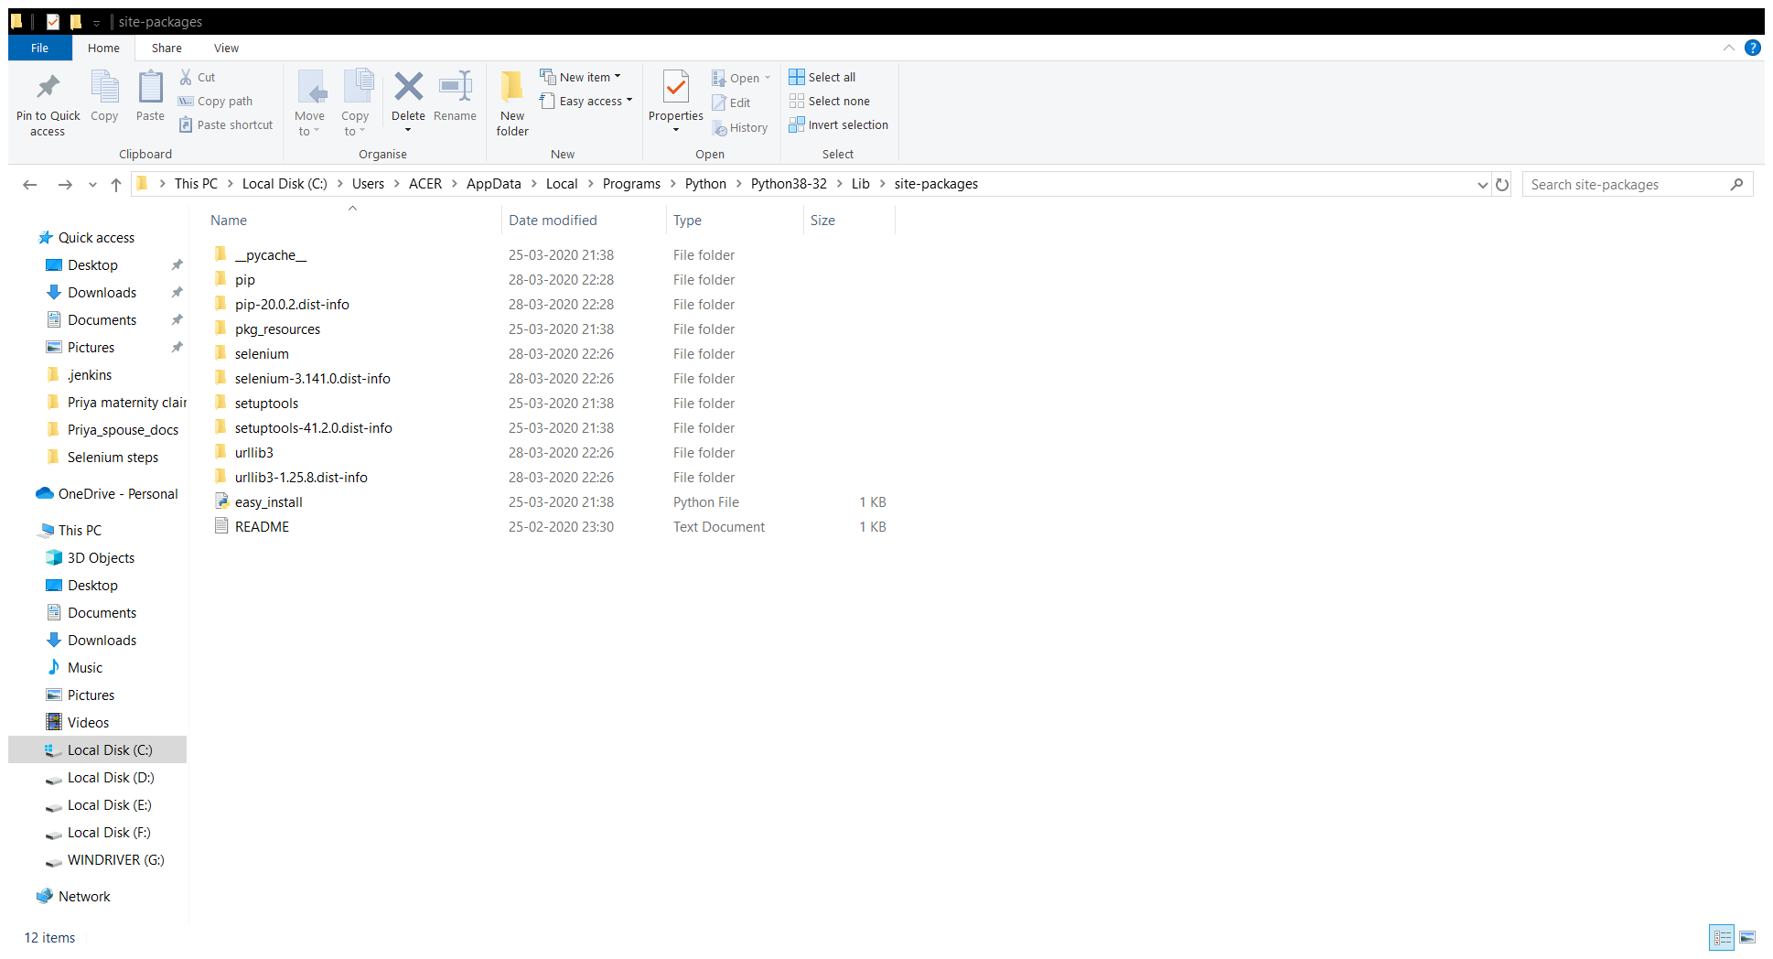

C:\Users\ACER\AppData\Local\Programs\Python\Python38-32\Lib\site-packages\selenium\webdriver\chrome

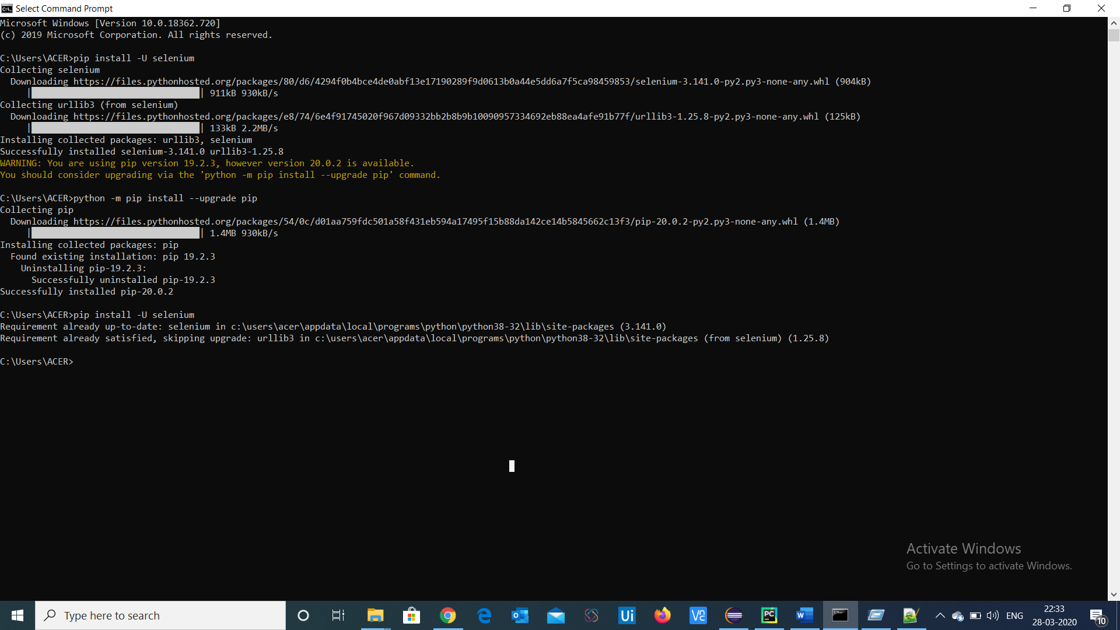

Download the updated version of pip

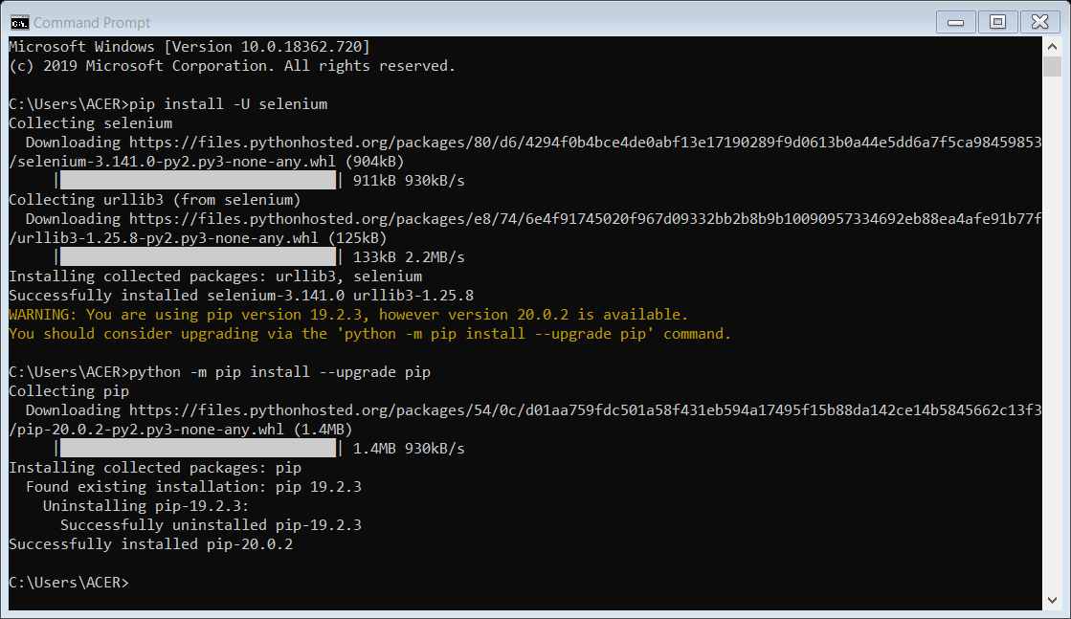

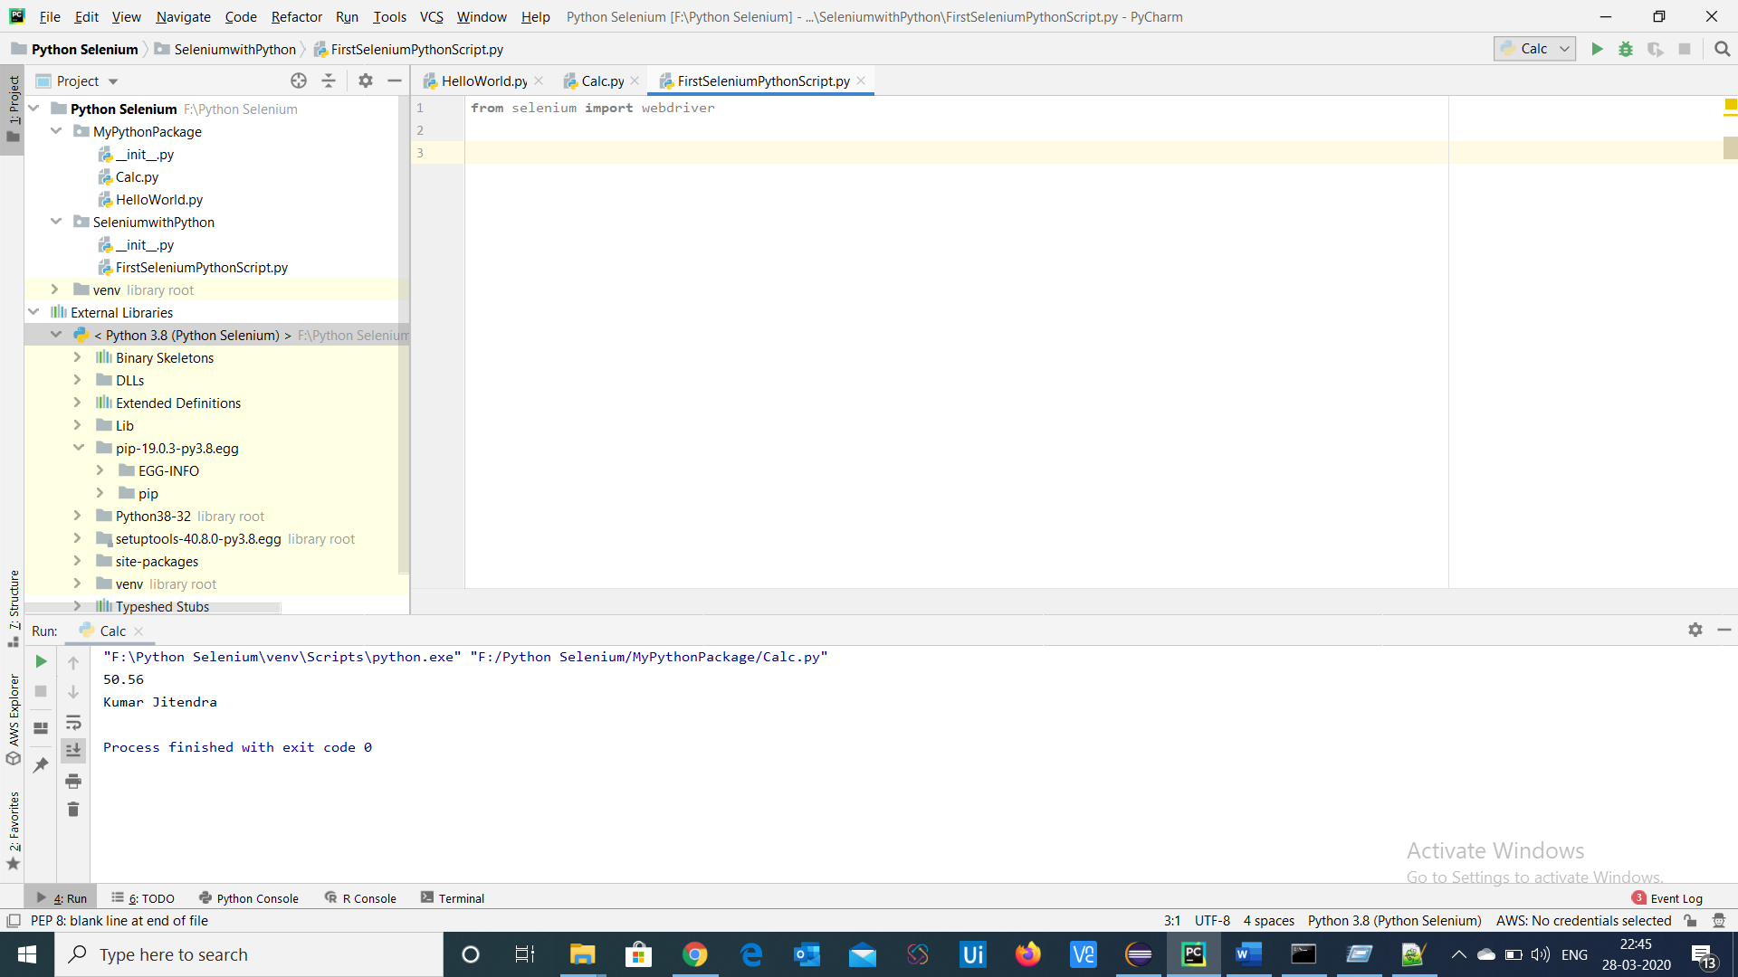

It will import the webdriver

To install pytest :- pip install pytest

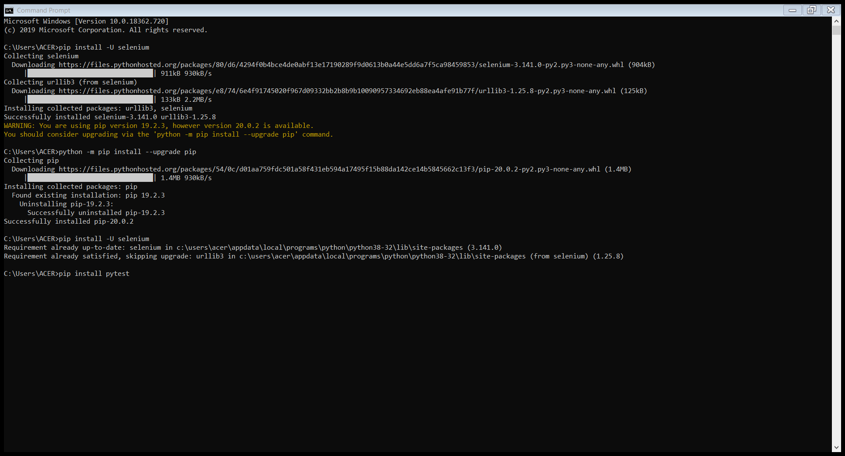

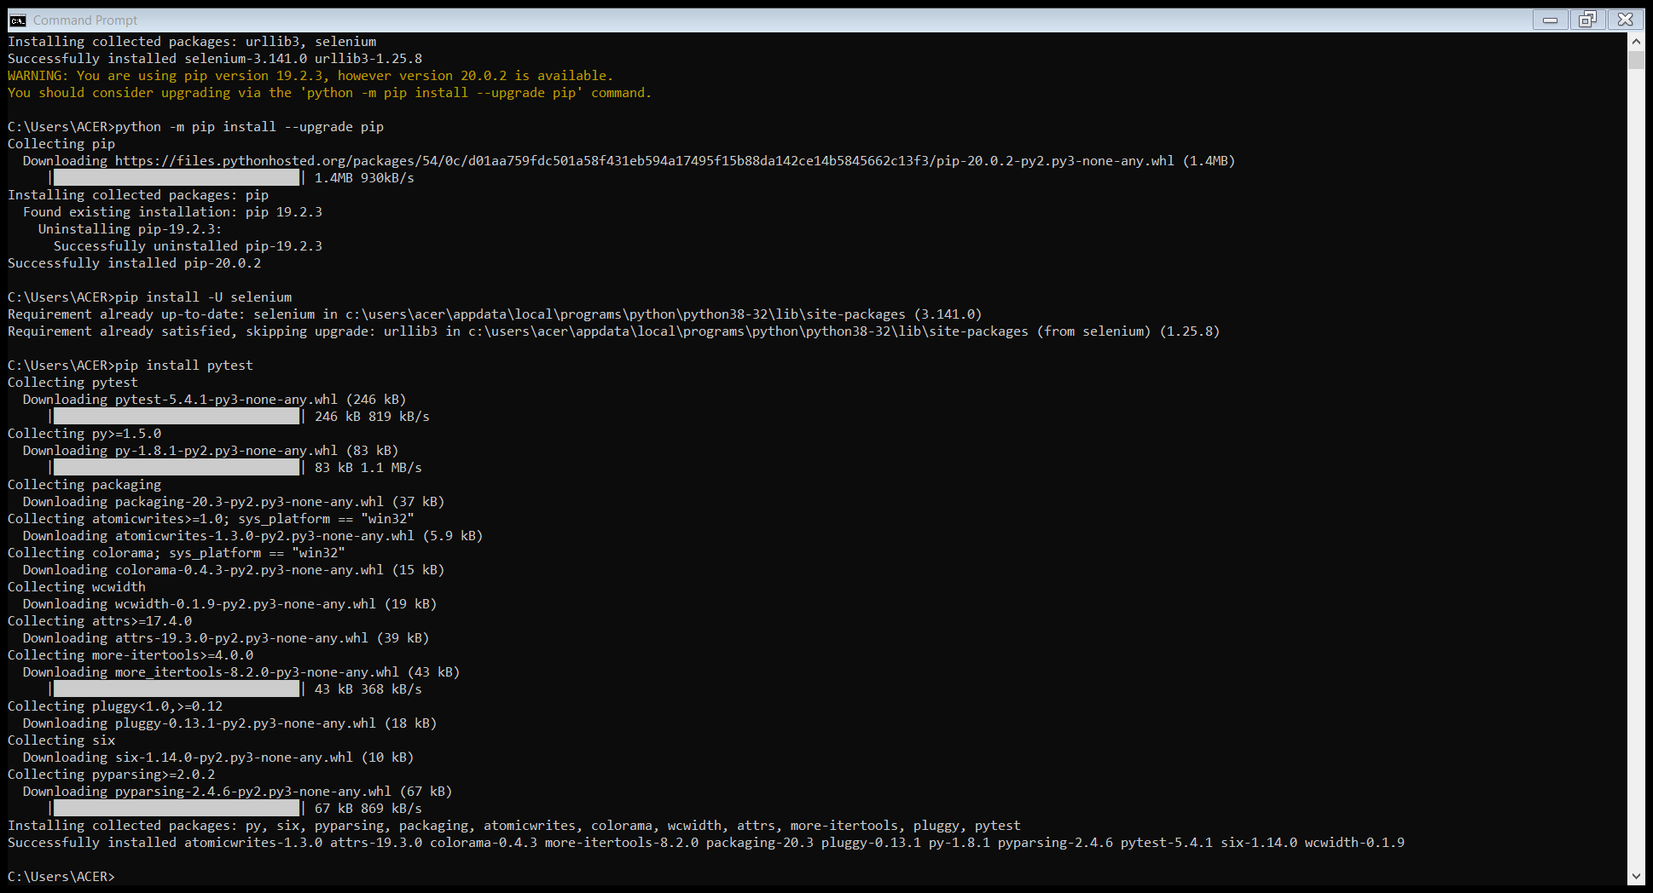

File>settings > Interpreter -selenium will be installed and present

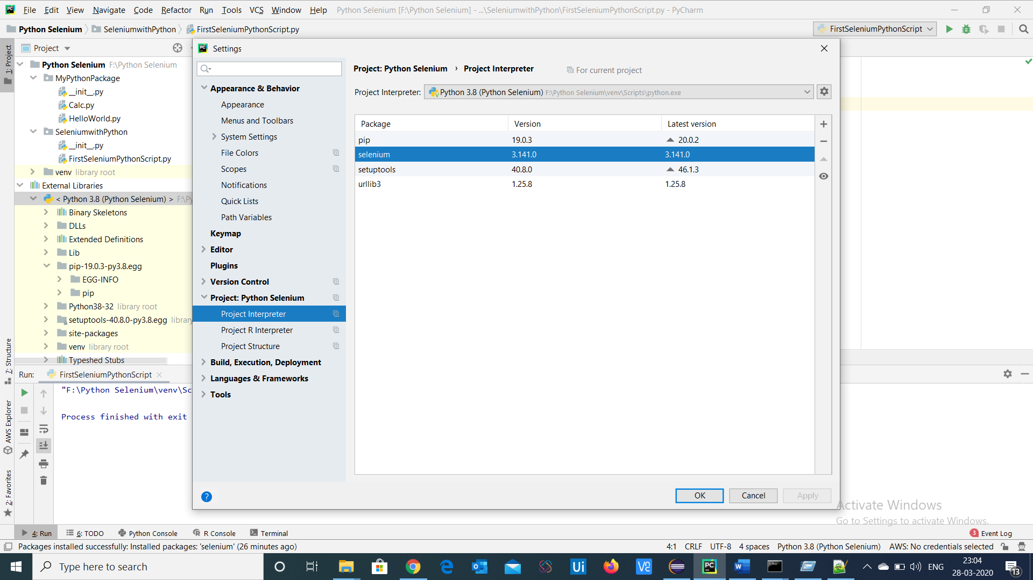

Add the package for pytest

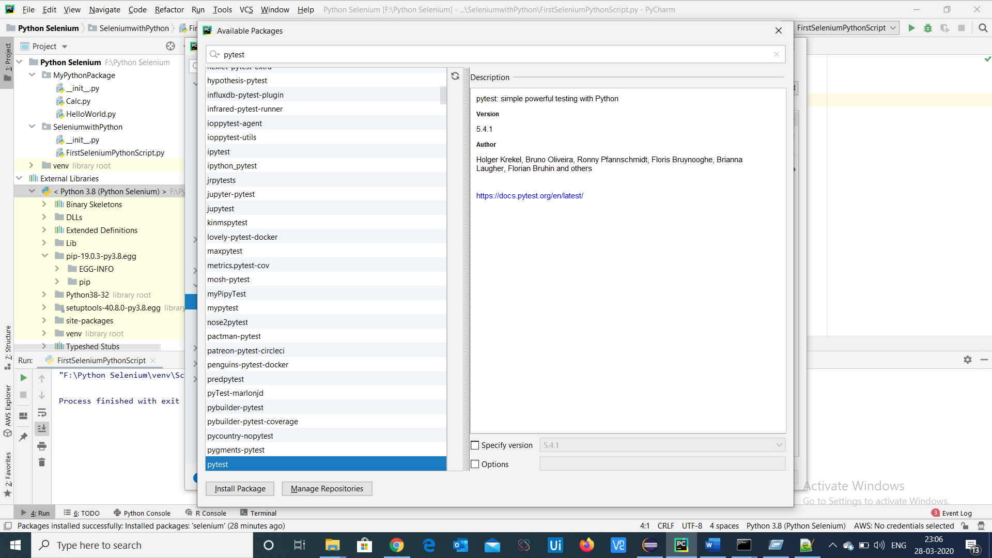

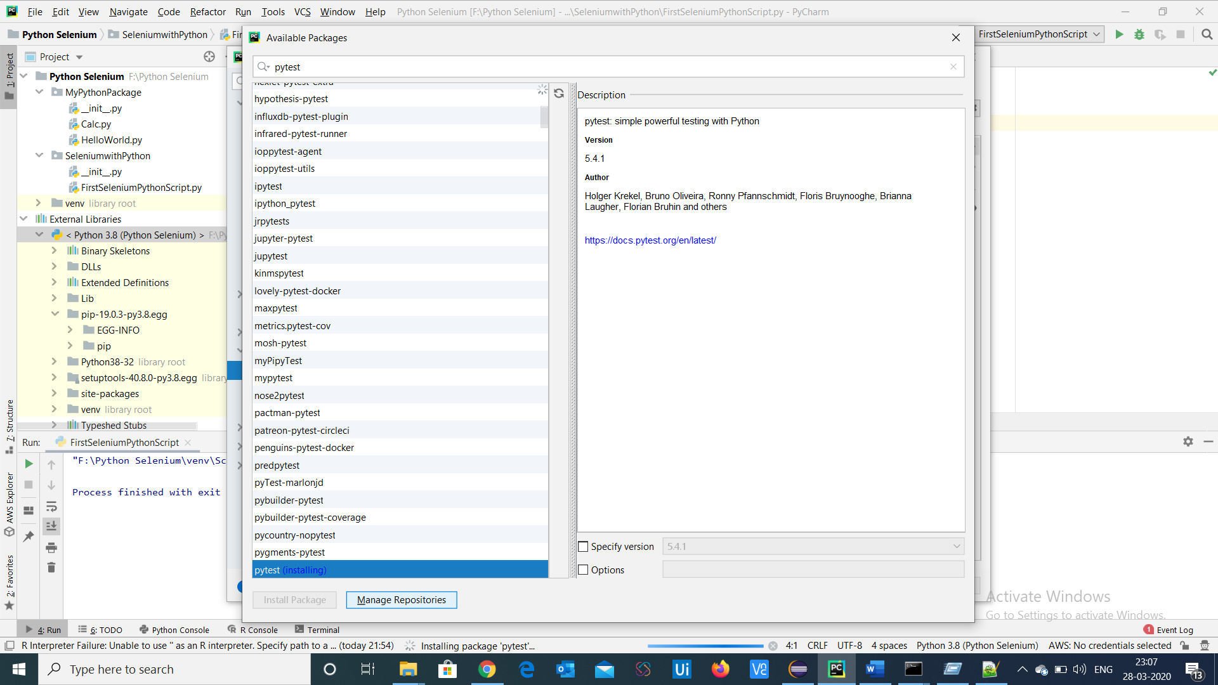

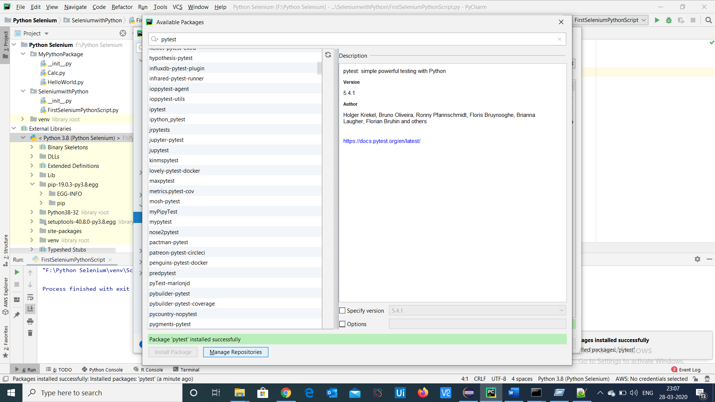

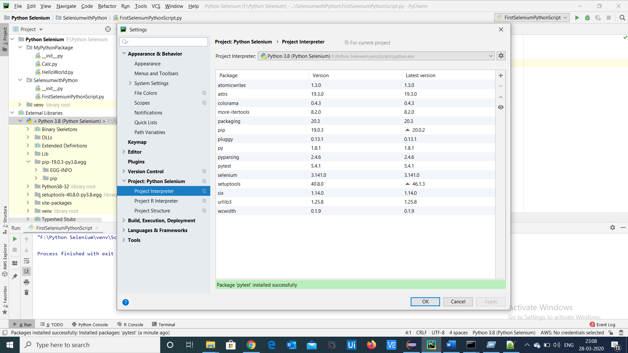

Now we can see the piy – pytest package installed

Now import the pytest package inside the class and import selenium wedriver

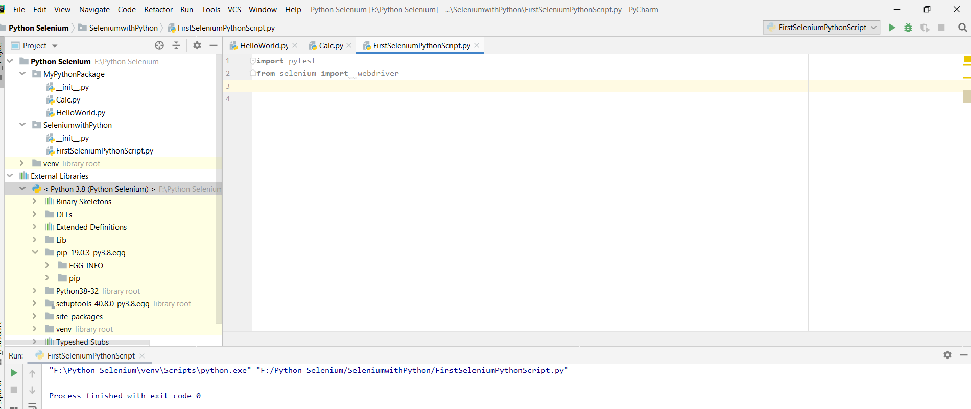

Run through pytest

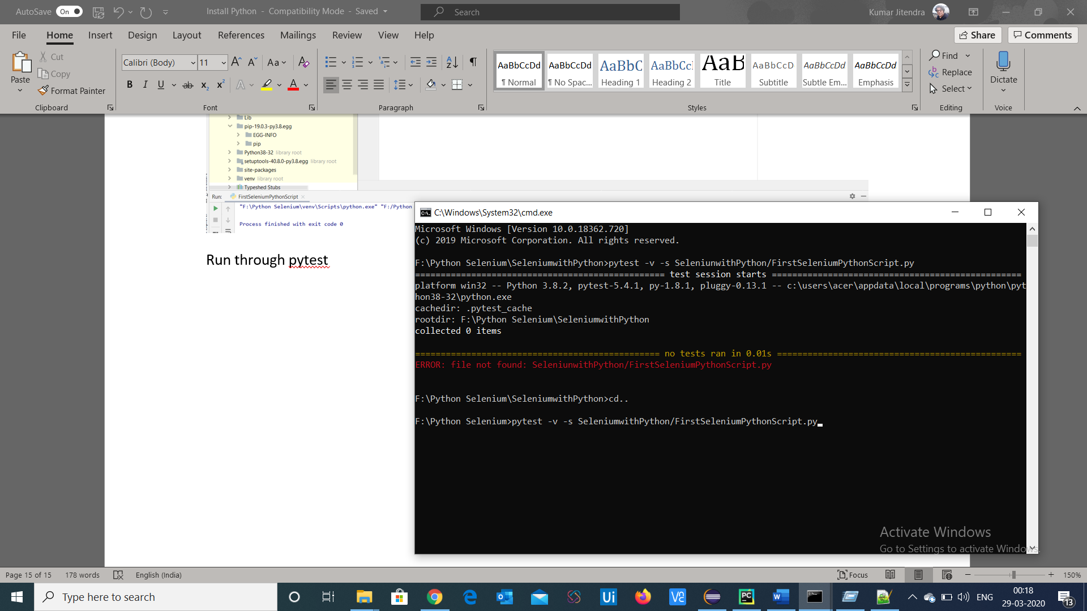

Create new file in python (new project)

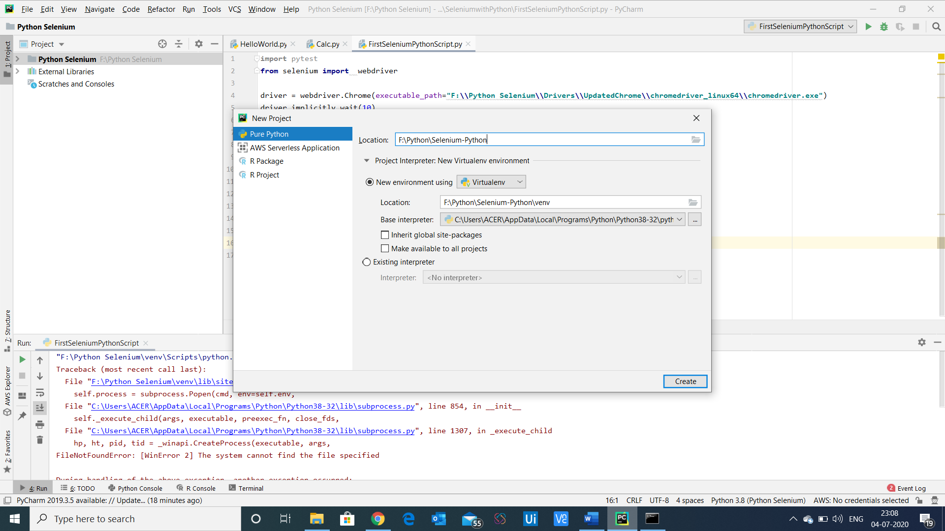

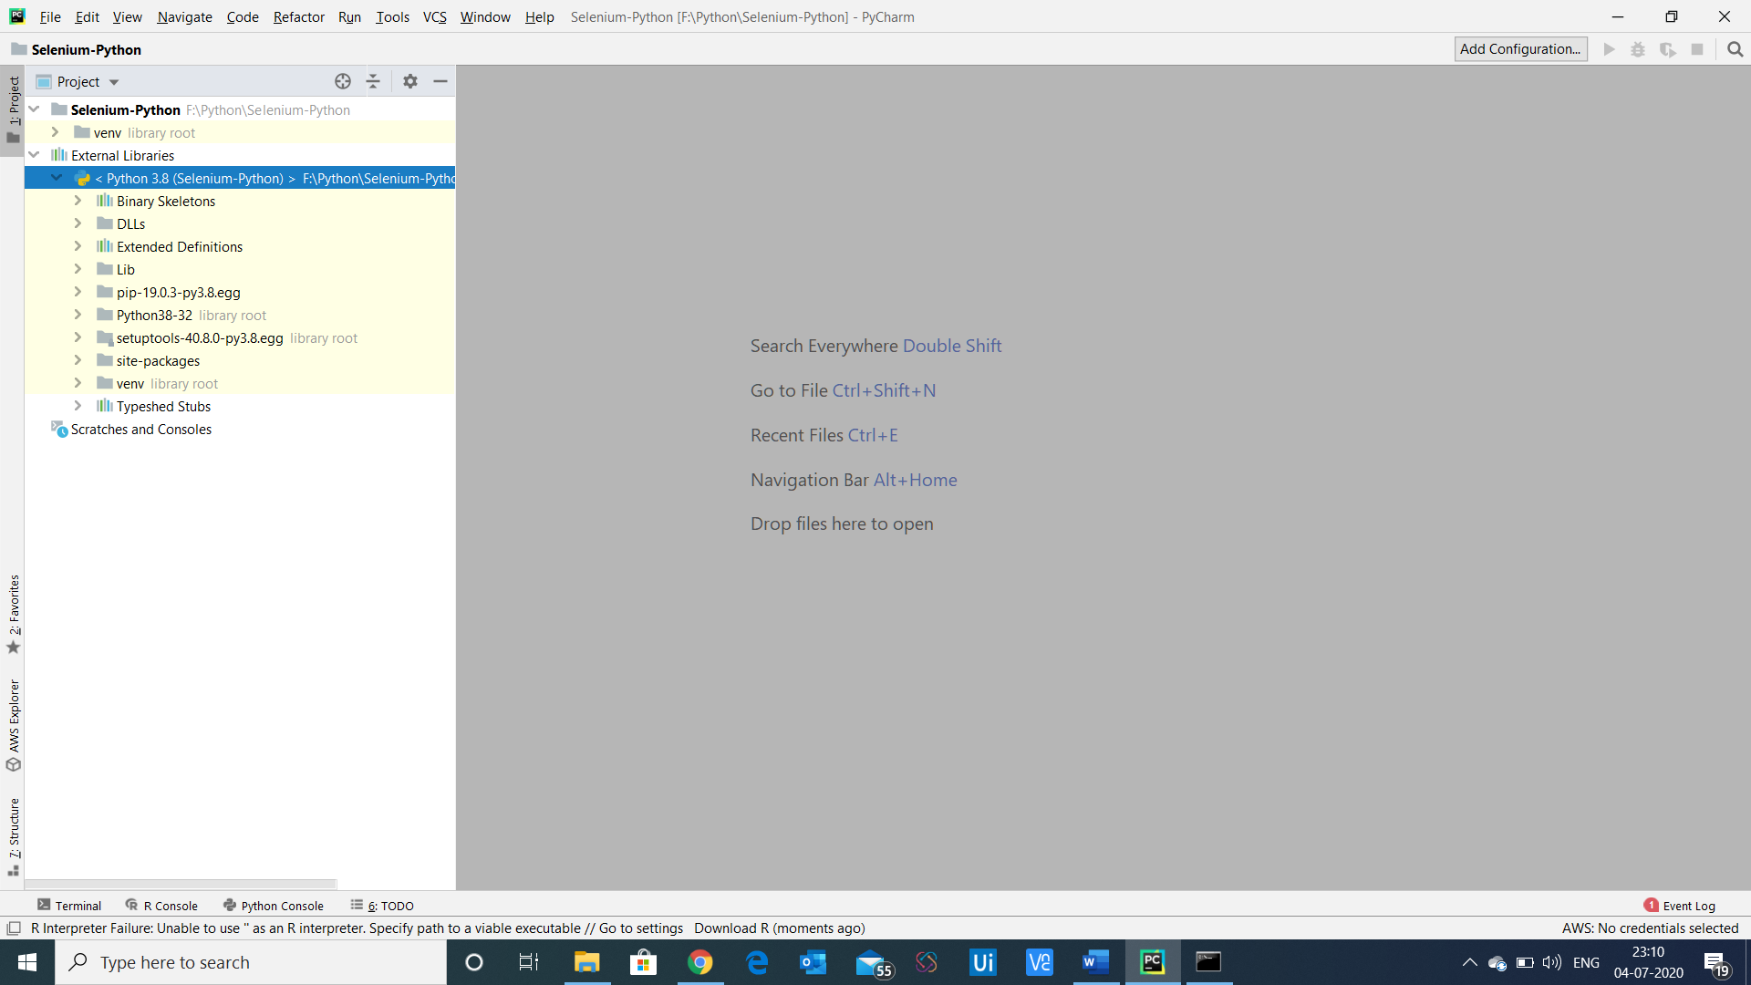

New file project would be created

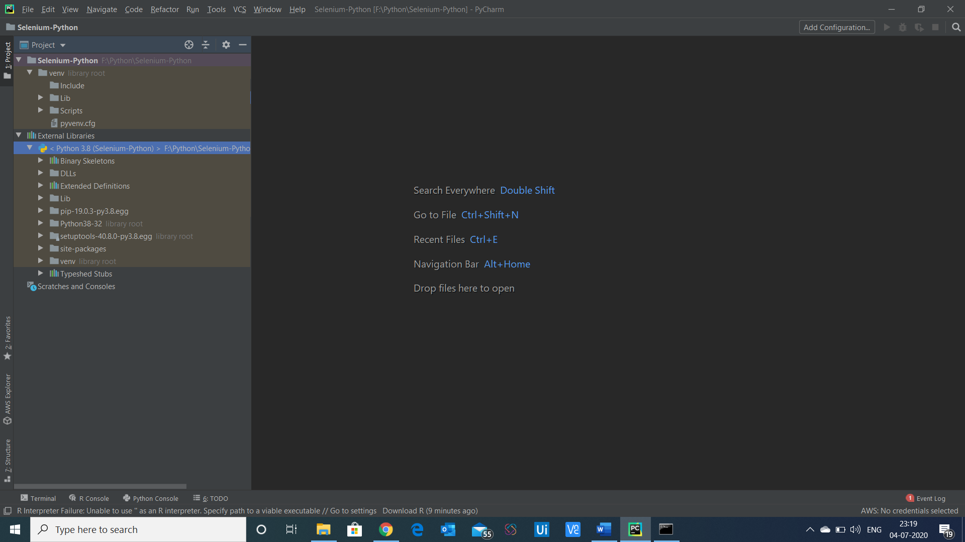

Select open in terminal

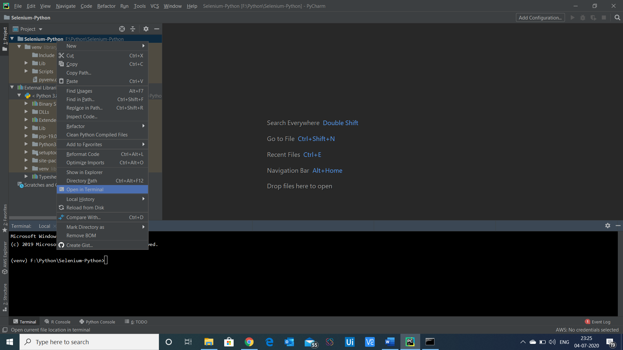

Pip install -u selenium

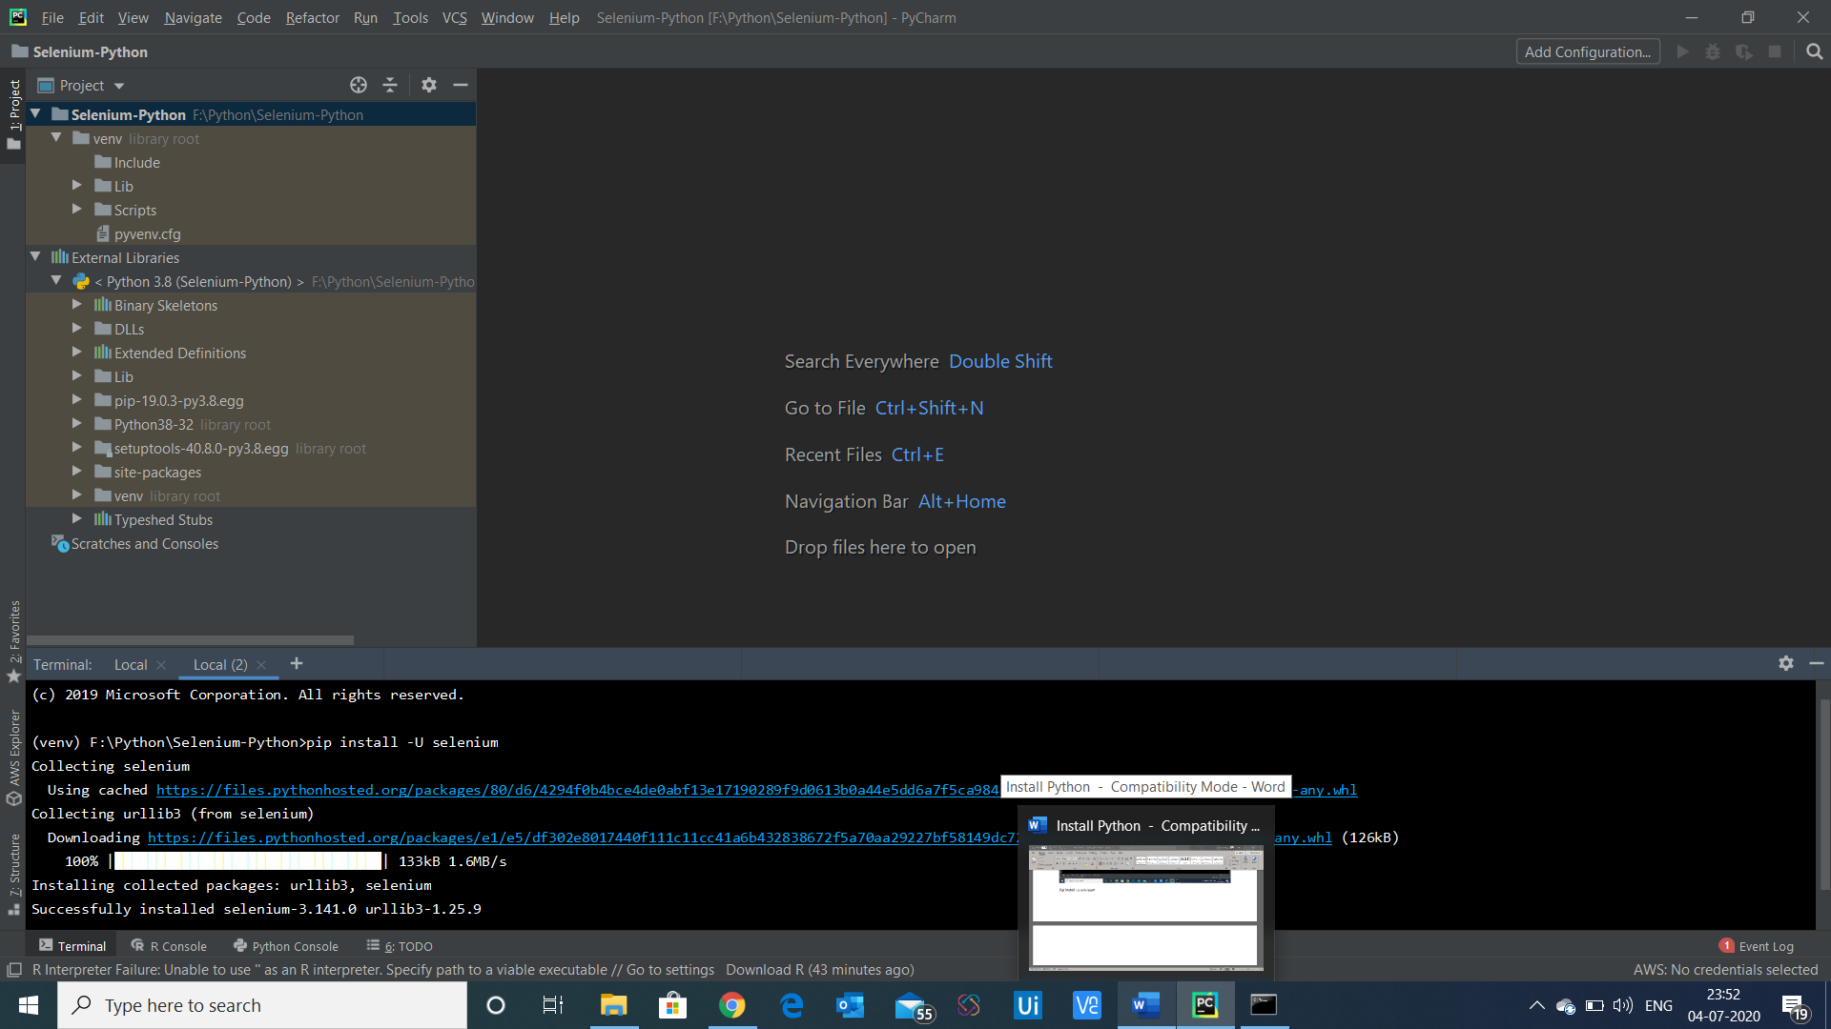

Selenium 3.14.0 is installed

Now create package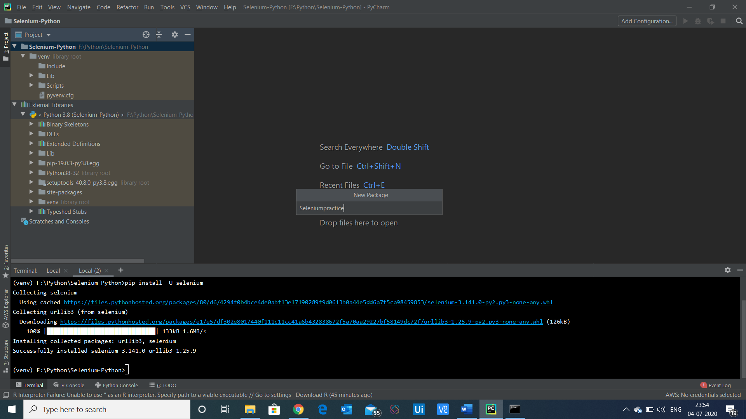

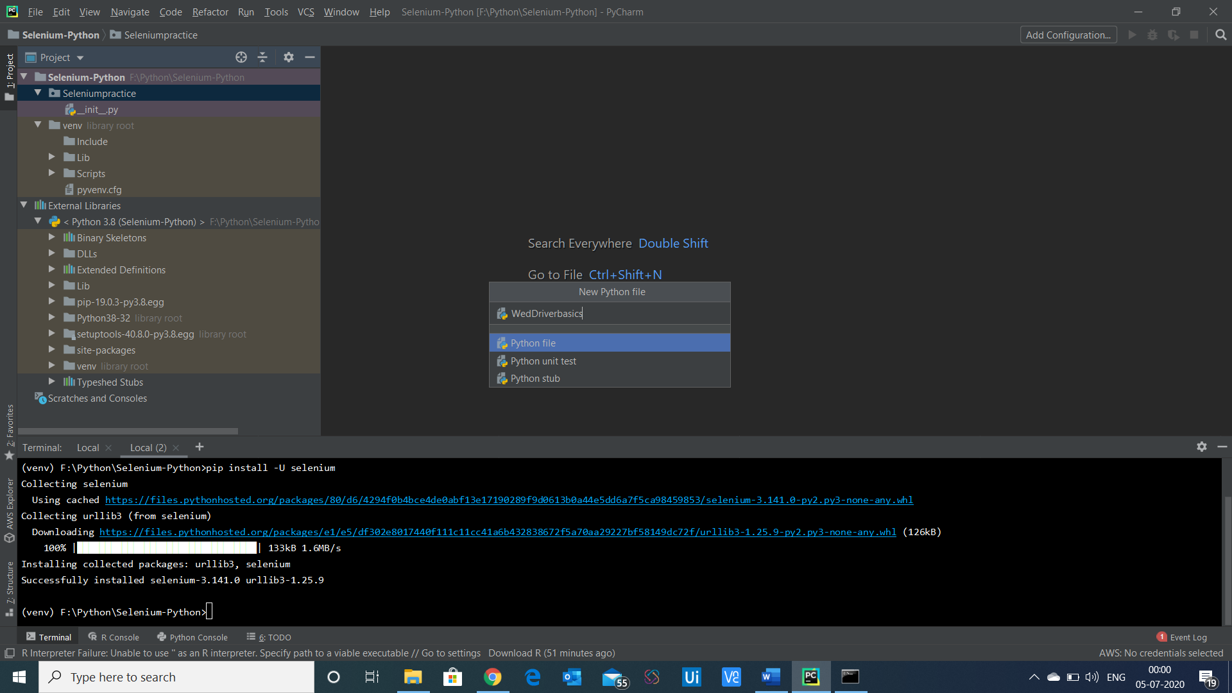

Create new python file

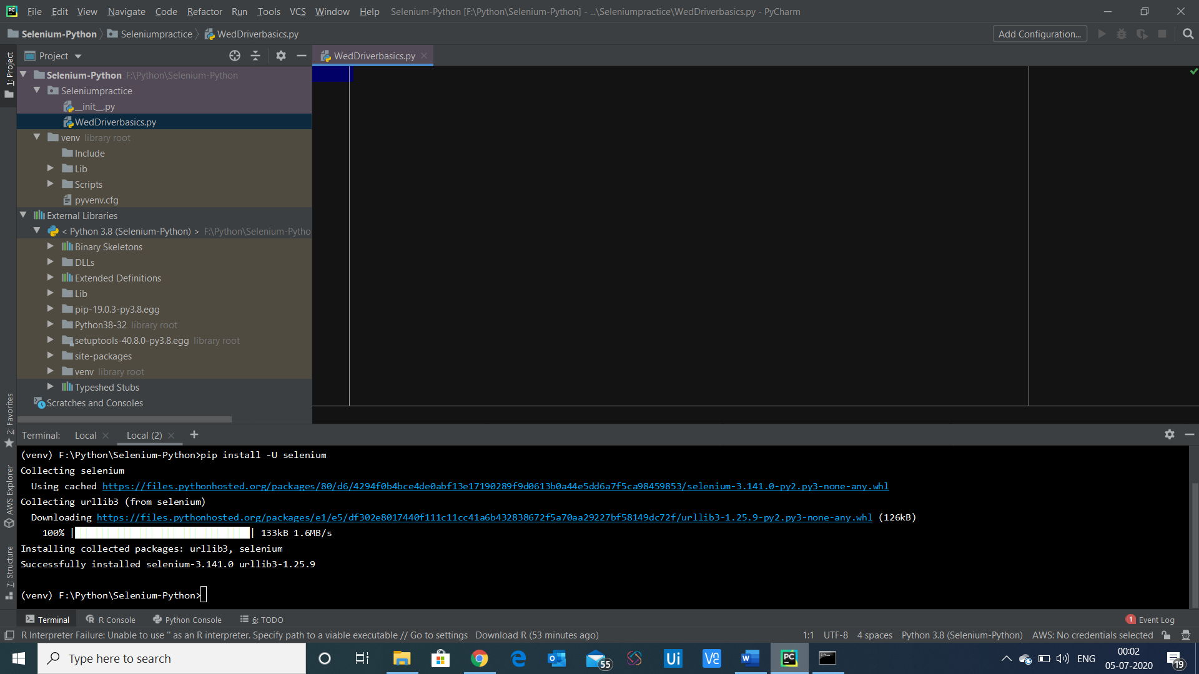

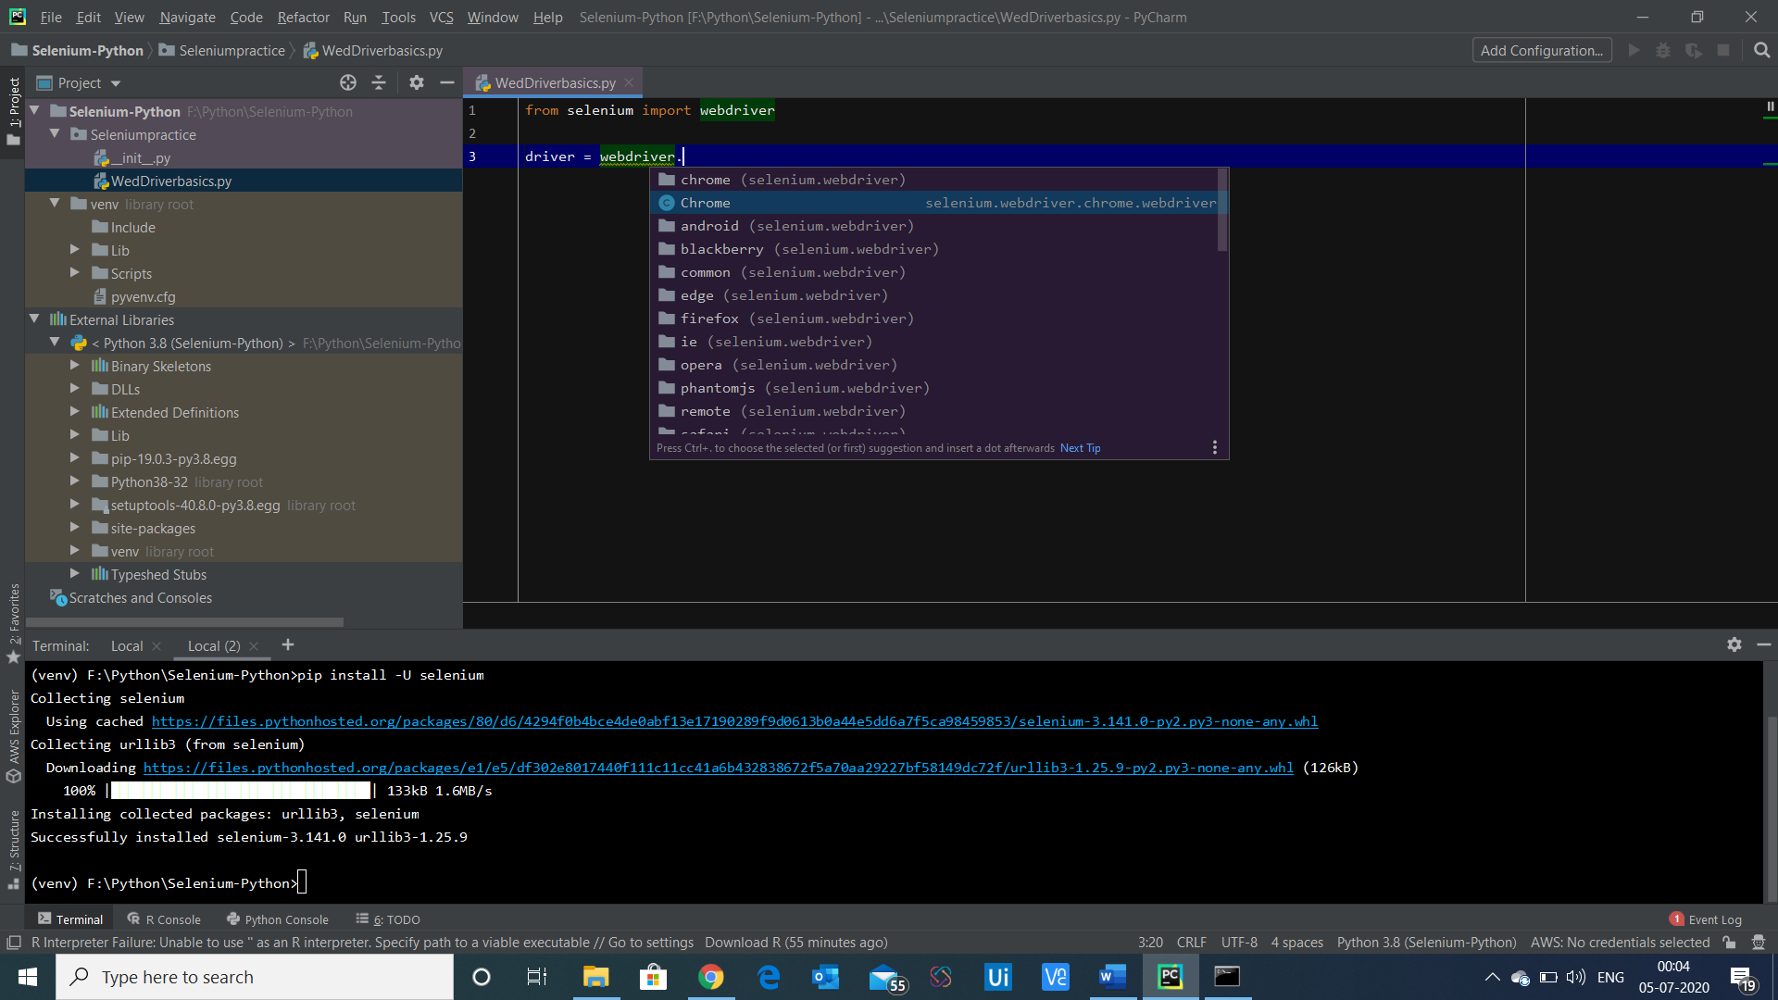

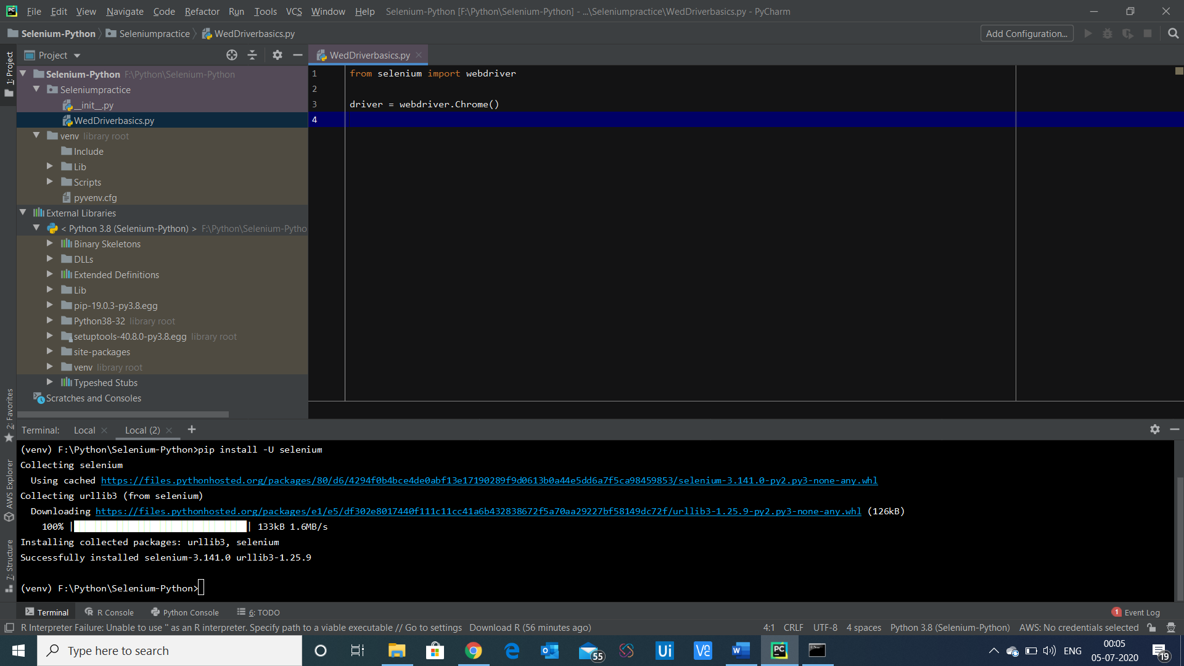

From – selenium package install webdriver

Download the chrome driver

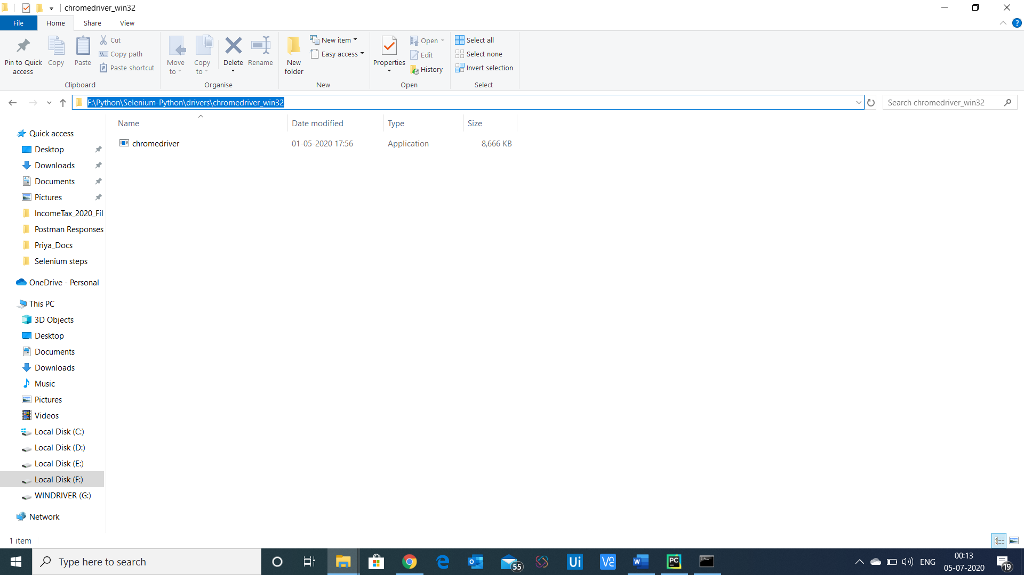

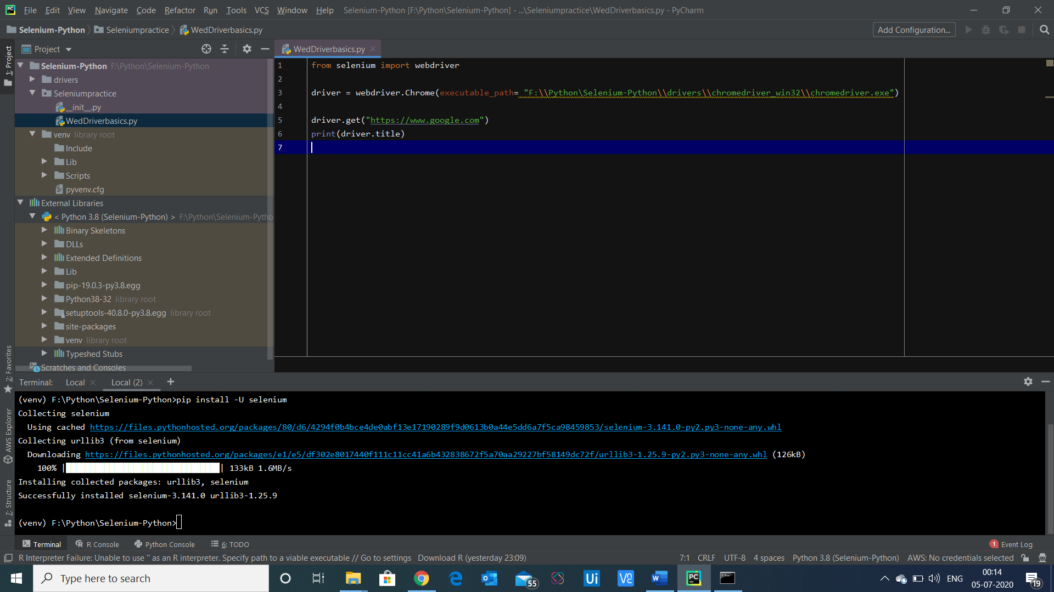

Give the driver executable path

To run the code

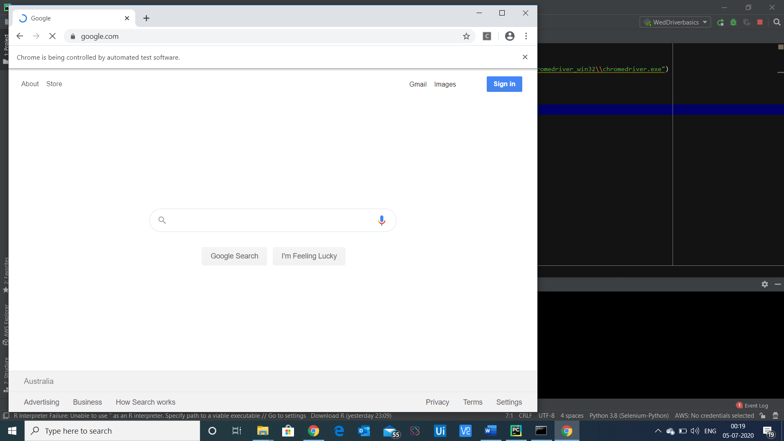

Add implicit wait

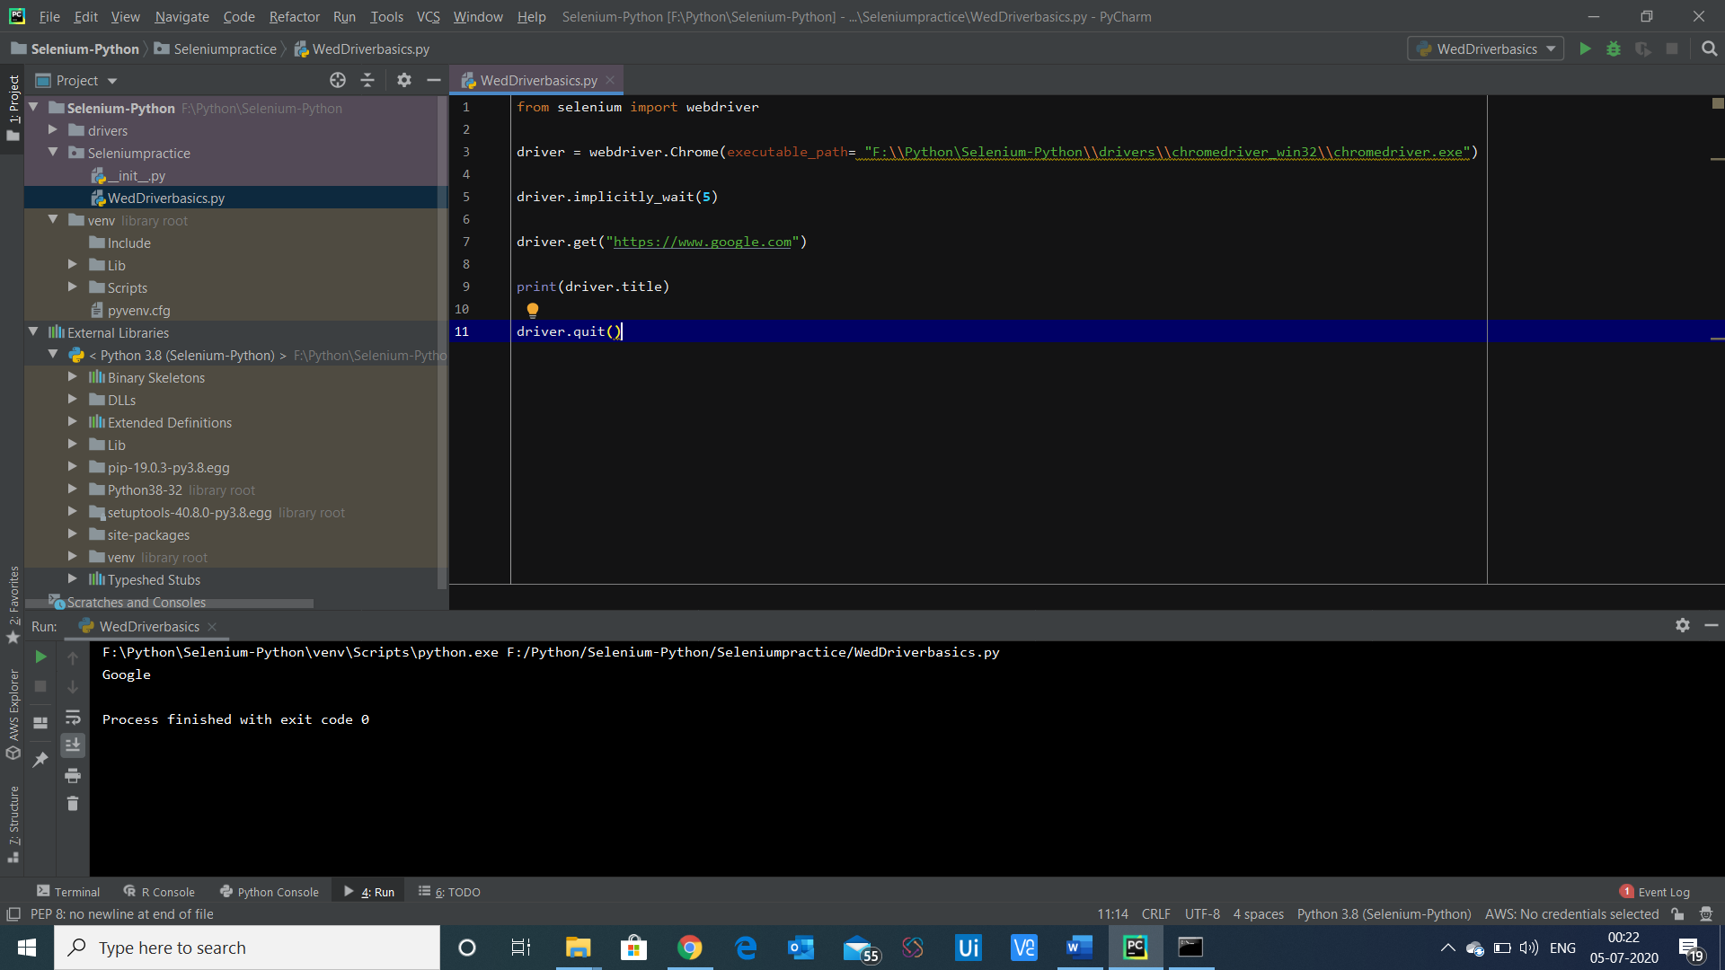

Import the By package

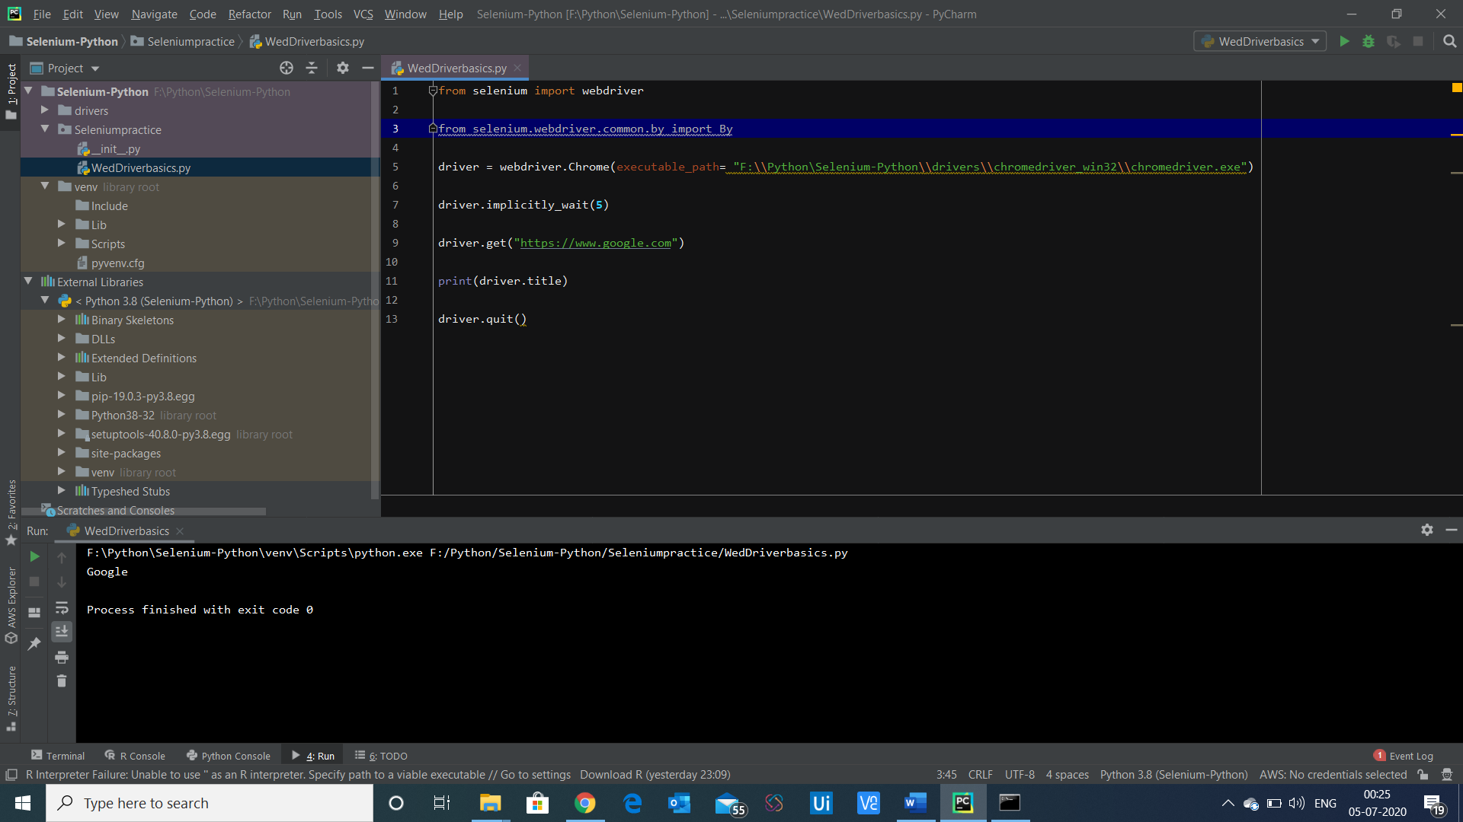

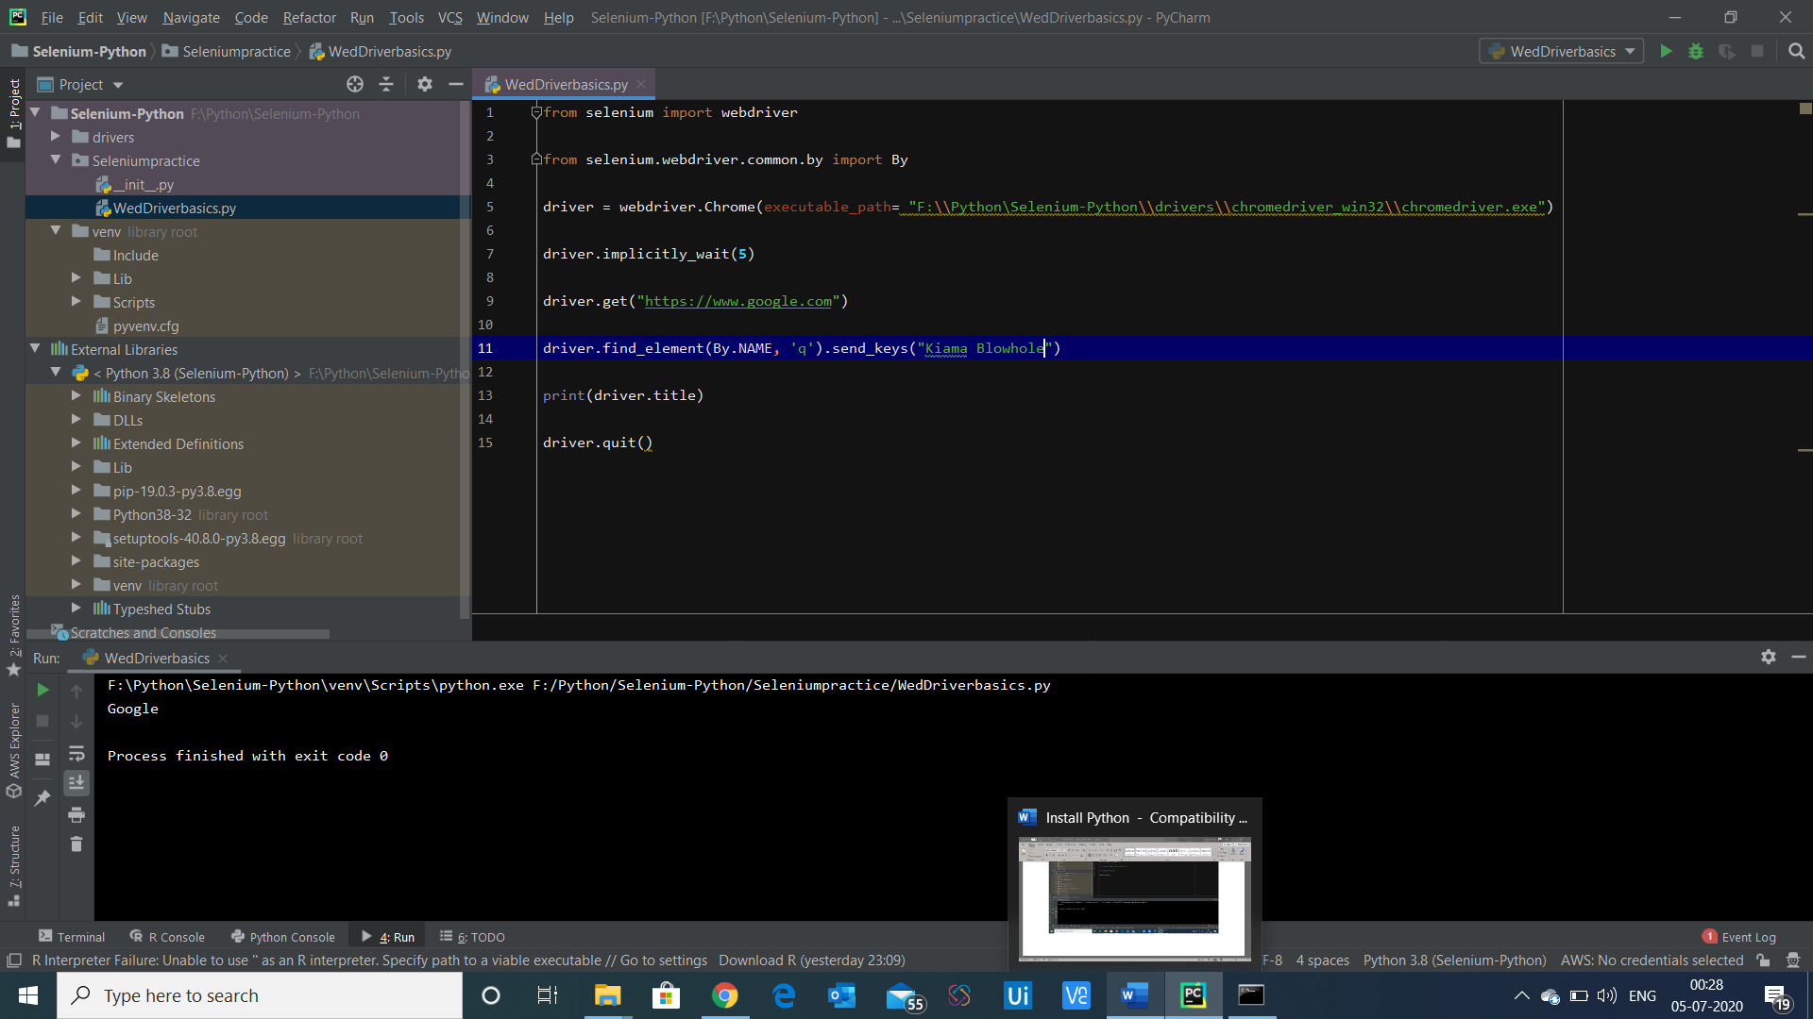

Import time package to select time.sleep method

It will behave same as thread.sleep

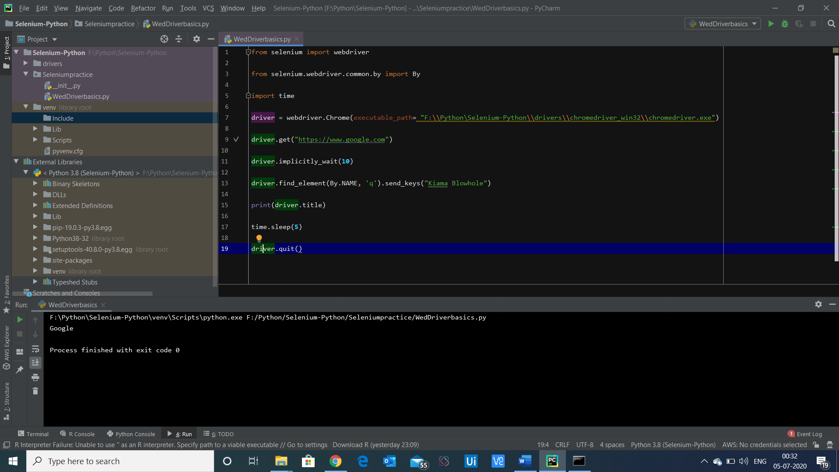

To use the find elements example using optionLists and for loop and if condition

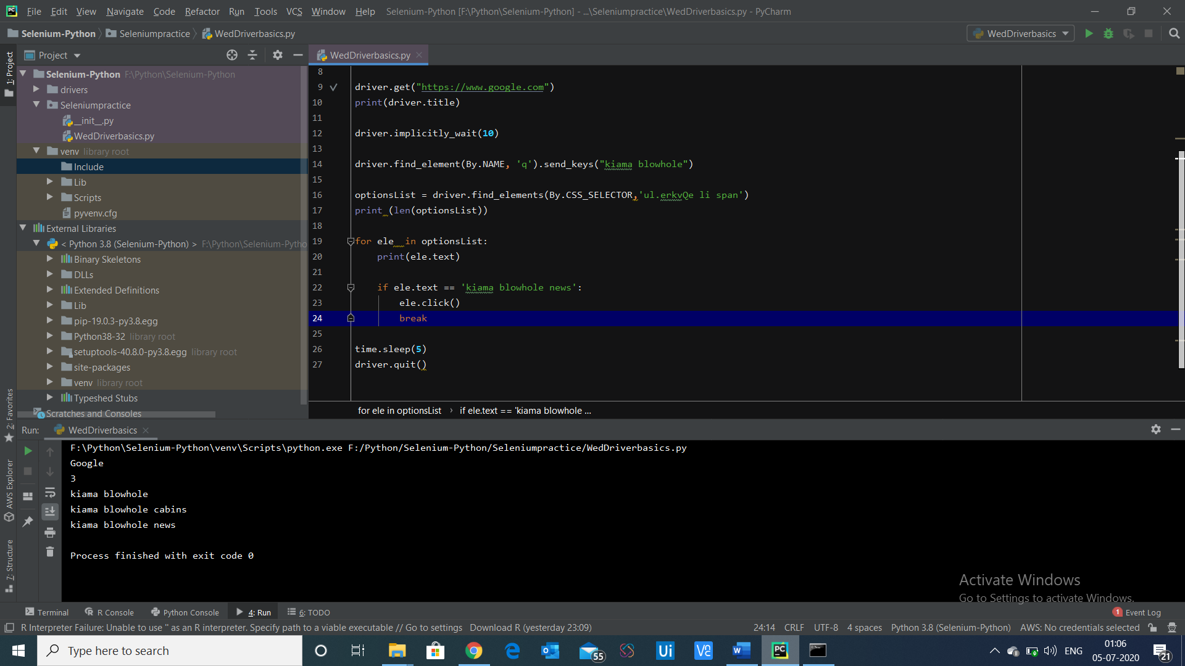

Run the Python program using Terminal – using command prompt

Run using cmd prompt

python Webdriverbasics.py

TO run the code on Python IDLE – just type Python it will open the Python IDLE

[The Python Tutorial — Python 3.8.13 documentation](https://docs.python.org/3.8/tutorial/index.html)

